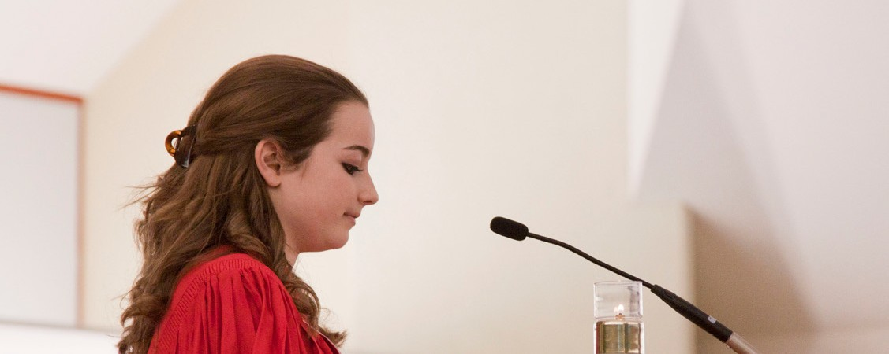

A STEWARDSHIP MOMENT

# Twenty-Second Sunday in Ordinary Time Weekend of September 2/3, 2023

In today’s Gospel reading, Jesus brings up the topic of the cross to his followers. They would not realize the cross was part of God’s plan and was to be their legacy until after the Resurrection. Today’s followers of Christ

recognize they are stewards of his entire legacy, including his cross; that through their mutual sacrifices God’s glory is revealed. They don’t live their lives in Christ only when it is convenient for them. They make a decision to take

up their cross and carry it, no matter what the cost. In the midst of the uncertain times we live in, what crosses do we bear in order to reveal God’s glory?

# Twenty-Third Sunday in Ordinary Time Weekend of September 9/10, 2023

In Saint Paul’s letter to the Romans he suggests that God lavishes his love upon us through Jesus Christ, who calls us to the kind of loving relationship, if we so choose

it, that demands accountability. It is like, in Saint Paul’s vocabulary, a kind of “debt” that we can never “pay-in- full.” But we begin to repay by following the direction of one of the most familiar statements in the Bible: “Love your neighbor as yourself.” Good stewards realize that God does not call them just to love those who are easy to love, but to love the unloved and the hard-to-love people in this world as well. This week, remind yourself: “I am put here as an ambassador of God’s love.”

# Twenty-Fourth Sunday in Ordinary Time Weekend of September 16/17, 2023

Today’s Gospel reading continues Jesus’ instructions on being good stewards of others – the direction that if we love Jesus Christ, we must forgive an individual 77 times. The reading compels us to consider one of the most difficult practices of Christian discipleship. Forgiveness

is the way of Jesus, the way of the cross. Vengeance, bitterness and hatred seem so much easier and certainly more desirable. Forgiveness is a hard road to travel, but it is the only road that leads to life in Christ. Consider this week who you need to forgive.

# Twenty-Fifth Sunday in Ordinary Time Weekend of September 23/24, 2023

From an early age, we tend to distort the concept of “fairness”: “I am good. I deserve good things. I am not receiving good things. Something must be wrong. Who’s going to fix it?” We also know the age-old expression: “Who ever said life was fair?” Jesus knew this expression when he offered his parable in today’s Gospel reading. Christian stewards acknowledge, with humility, that they receive good things from the Lord in abundance; even

if these gifts are not the ones they think they need when they need them. Consider which servants you identify with most in the Gospel reading, the ones who demand “fairness”, or that final servant who, seemingly, deserves the least.



International Catholic Stewardship Council

[ICSC@catholicstewardship.org](mailto:ICSC@catholicstewardship.org)

(800) 352-3452

[**www.catholicstewardship.com**](http://www.catholicstewardship.com/)