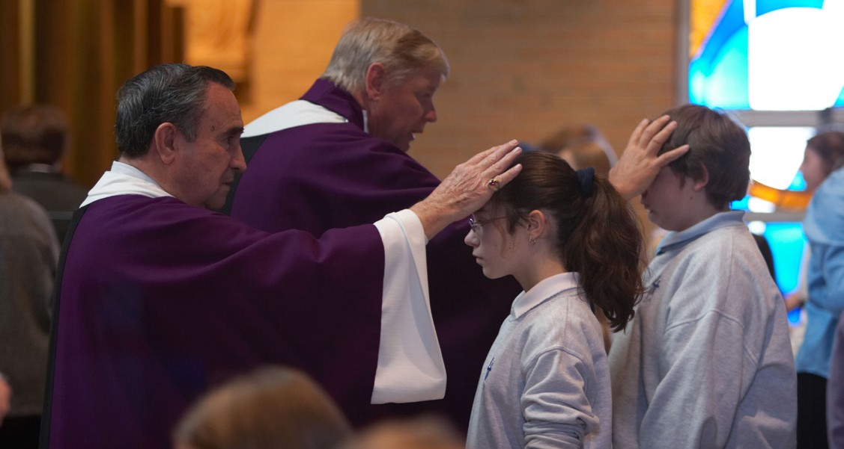

A STEWARDSHIP MOMENT

**Second Sunday of Lent Weekend of March 4/5, 2023**

In today’s second reading, Timothy is issued a strong directive: “Bear your share of hardship for the gospel with the strength that comes from God.” For the early Christians this could mean torture and execution. For most Christians today enduring hardship for the Gospel might include accepting ridicule or mockery, or the suggestion that

we lack sophistication. Nevertheless, in his letters, Saint Paul is adamant that we should not be ashamed of being followers of Christ. Good stewards are not ashamed of their allegiance to Christ. They do not hide their faith. Reflect

on this question: Are you willing to speak about following Christ Jesus no matter who your listeners happen to be?

**Third Sunday of Lent**

**Weekend of March 11/12, 2023**

Jesus’ longest-recorded conversation with anyone is the one he has with the Samaritan woman at the well. She discovers she can be honest with Jesus and goes and tells others about him. She gives witness. She’s not the most certain, thorough or even convincing witness. But her witness is enough. It is inviting, humble, non-judgmental and sincere. What is the quality of our witness? How do our words and actions give daily testimony on behalf of Christ? During this season of Lent, how might we do a better job at proclaiming the risen Lord in word and deed?

**Fourth Sunday of Lent**

**Weekend of March 18/19, 2023**

Saint Paul gives us a wakeup call. As stewards of the light of Christ, we are to reflect that light with the help of the Holy Spirit. If Christ’s work has transformed and

illuminated our lives, there should be a change. The light of Christ’s active presence should be at work in us. And as the light shines within us, we take on the properties of that light and we shine too. We are used by God to shine the light of Christ in the lives of others. A challenging Lenten reflection: Is the light of Christ shining in our hearts? Is the light of Christ reflecting out from us to others?

**Fifth Sunday of Lent**

**Weekend of March 25/26, 2023**

Jesus called to his friend from the dead, “Lazarus, come out!” It is the same call our Lord makes to us unceasingly: “Come out!” Jesus calls us from our tomb of doubt and unbelief, from the darkness of our fear and anxieties; from the depths of our weaknesses and lack of hope. Christian stewards pray for an open heart so that they may hear the voice of the Lord, heed the continuous call to come away from their former way of living and reprioritize their lives in the light of the Gospel of Jesus Christ. Do we believe Christ has the power to transform our lives? Do we take time to listen for his call?



International Catholic Stewardship Council

[ICSC@catholicstewardship.org](mailto:ICSC@catholicstewardship.org)

(800) 352-3452

[**www.catholicstewardship.com**](http://www.catholicstewardship.com/)