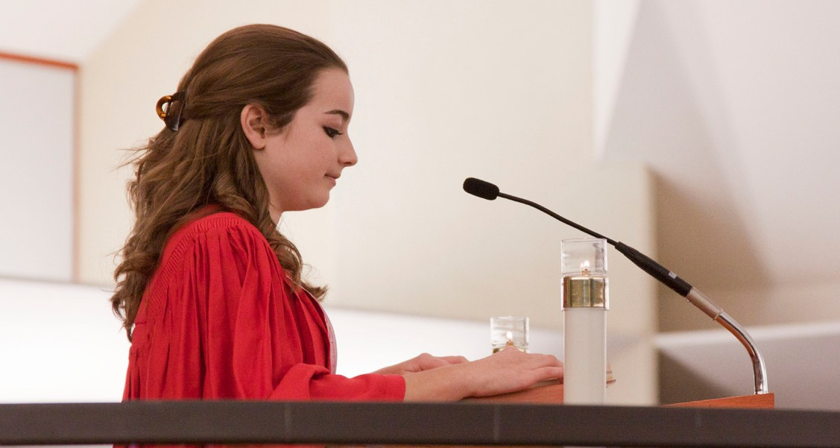

A STEWARDSHIP MOMENT

# Fifth Sunday in Ordinary Time Weekend of February 4/5, 2023

In this weekend’s readings and psalm, the prevailing theme is that of light: We are the light of the world; our light breaks forth like the dawn; our light shines in the darkness; our light reflects generosity and justice. Good stewards know they are the lamp, and Christ is the flame that, through them, illuminates the earth. They know that they carry Christ’s light in their hearts, and let it shine through their words and deeds. What are we doing to shine Christ’s light on the hungry, the homeless and others most in need of God’s mercy? How do we exercise good stewardship over the light of Christ that burns within each of us?

# Sixth Sunday in Ordinary Time Weekend of February 11/12, 2023

In today’s Gospel, part of his Sermon on the Mount, Jesus does not speak of replacing the law of the Old Testament. He goes beyond it. He obliges his followers to work at being holier than even the strictest of Pharisees. But the work is not accomplished by following a religious “law”, it requires growing in love for other human beings. Followers of Jesus know they are required to be good stewards of others. In what way will you exercise good stewardship over other people this week?

# Seventh Sunday in Ordinary Time Weekend of February 18/19, 2023

In another passage from his Sermon on the Mount, Jesus continues to turn his disciples’ way of thinking upside- down. One of the lessons for the Christian steward in today’s Gospel is that if we have a chance to help someone in need, we should be generous and give more than is expected of us. Jesus went “the extra mile” for us. Can we be more like Jesus and “go the extra mile” for others?

# First Sunday of Lent

**Weekend of February 25/26, 2023**

In today’s Gospel reading we listen to the confrontation between Jesus and the devil, who thought he might tempt Jesus to forget who he was and commit a grievous sin when he was most vulnerable. Jesus had just spent 40 days and nights out in the desert, alone, away from civilization. He was hungry, thirsty, and tired. If there ever was a time to tempt Jesus, that was it. Temptations to sin come at us every day, from many directions and in many different forms. When the temptation to sin tries to overcome us, how do we react? Do we consciously remind ourselves that we are followers of Christ? Is there a time this week when you have needed to confront a temptation to sin?

What lessons did you take away from the experience?



International Catholic Stewardship Council

[ICSC@catholicstewardship.org](mailto:ICSC@catholicstewardship.org)

(800) 352-3452

[**www.catholicstewardship.com**](http://www.catholictewardship.com/)