Word of Life – July 2022

Bulletin Quotes
July 3rd  “O God our creator… through the power and working of your Holy Spirit, you call us to live out our faith in the midst of the world, bringing the light and the saving truth of the Gospel to every corner of society.”  United States Conference of Catholic Bishops  “Prayer for Religious Liberty” | 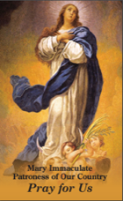  Order | Download
July 10th  “Adopting Andrew has made us more aware of God's power and of his love for us. We realize that he always has a perfect plan for our lives.”  Read more at www.bit.ly/AdoptionLoveStory.  USCCB Secretariat of Pro-Life Activities  “An Adoption Love Story” | 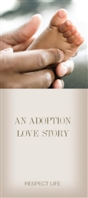  Order | Download
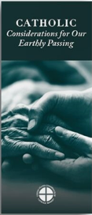
July 17th
“Because of our belief and hope in the Resurrection, we can face death not with fear, but with preparation…. We prepare for eternal life by choosing to love and follow God now, in our daily lives and decisions.” Read more at www.respectlife.org/end-of-life-considerations.
USCCB Secretariat of Pro-Life Activities
“Catholic Considerations for Our Earthly Passing”
Order | Download

July 24th  “Married love differs from any other love in the world. By its nature, the love of husband and wife is so complete, so ordered to a lifetime of communion with God and each other, that it is open to creating a new human being they will love and care for together. … That power to create a new life with God is at the heart of what spouses share with each other.”  United States Conference of Catholic Bishops  “Married Love and the Gift of Life” | Order | Download
July 31st  “A woman with an unexpected pregnancy may have any number of fears and challenges: facing judgment from her friends and family, losing her job or housing, or being abandoned by the father of her child. Following Mary’s example, we can ask ourselves how to better know these mothers, listen to them, seek understanding, and help them obtain the necessities of life for themselves and their children.”  USCCB Secretariat of Pro-Life Activities  “Called to Serve Moms in Need” | 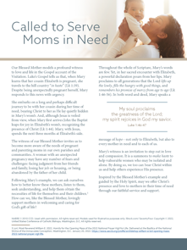  Download

Word of Life - July 2022

Bulletin Art
You are welcome to use these, provided they are not altered in any way, other than the size. Thank you!

Sunday, July 10th, 2022
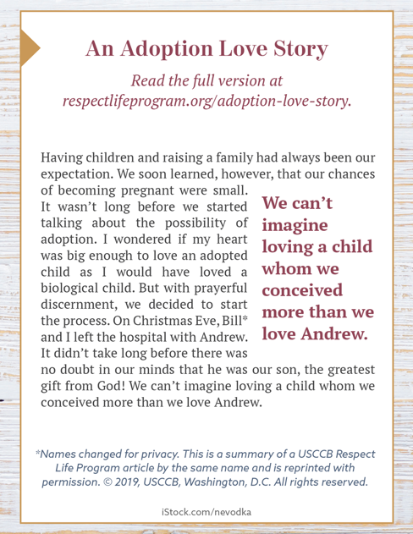
Download: English | Spanish

Sunday, July 24th, 2022
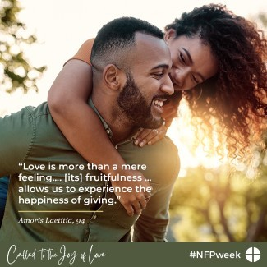
Download this and other graphics for NFP Week online.

