Word of Life: July 2022
Recommended dates are provided, but you are welcome to use these materials at any time!

Featured this Month

2022 Respect Life Resources: Called to Serve Moms in Need
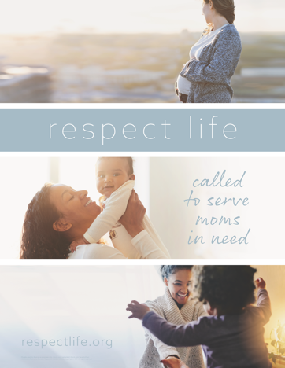
This year’s Respect Life materials focus on serving moms in need and are being released in two phases. (To be clear, a diocese or parish does not have to be in the process of launching “Walking with Moms in Need” in order to make use of this year’s materials, which highlight service to mothers.)

The first phase is being made available at www.respectlife.org/called-to-serve. You are welcome to use anything posted there immediately.

A second set of materials specifically for Respect Life Month will be released later in the summer for use during October.

National NFP Awareness Week: July 24-30, 2022
The dates of National Natural Family Planning Awareness Week highlight the anniversary of the papal encyclical Humanae vitae (July 25), which articulates Catholic beliefs about human sexuality, married love, and responsible parenthood. The dates also mark the feast of Saints Joachim and Anne (July 26), the parents of the Blessed Mother. Couples’ stories, sample intercessions, homily notes, graphics, and more can be found online.
Poster
PDF: English | Spanish JPG: English | Spanish

Feast of Saints Joachim and Anne: July 26, 2022
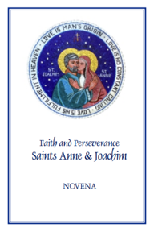
The Feast of Saints Anne and Joachim, parents of the Blessed Virgin Mary, is celebrated on July 26. They are powerful intercessors for all married couples, expectant mothers, and married couples who are having difficulty conceiving, as well as those who are aging. Copies of the “Faith and Perseverance” Novena to Saints Anne and Joachim are available for download or purchase. You can pray the novena from July 17-25 in preparation for their feast day.
Download: English | Spanish

