A STEWARDSHIP MOMENT

Nineteenth Sunday in Ordinary Time
Weekend of August 6/7, 2022

In today’s Gospel reading, Jesus concludes his teaching about those who are “faithful and prudent stewards” with that classic stewardship teaching: “Much will be required of the person entrusted with much, and still more will be demanded of the person entrusted with more.” Christian stewards recognize that God is the ultimate source of
their gifts, talents, resources and aptitudes, and that God wants them to use these varied gifts in his service. This week might be a good time to reflect on our God-given gifts. Are we using those gifts to serve the Lord? If Christ came back to us unexpectedly tomorrow would we be able to give a full accounting of how we have exercised stewardship over these gifts?

Twentieth Sunday in Ordinary Time
Weekend of August 13/14, 2022

In today’s second reading, we hear the author of the letter to the Hebrews liken the daily life of the Christian steward to a race, a long-distance race perhaps, certainly not a sprint; requiring endurance and a single-minded focus on Jesus at the finish line. Good stewards are firmly committed to running the race, to live the Christian life
to the fullest, to keep their eyes focused on Jesus. They don’t grow weary. They don’t lose heart. They know there is immense joy waiting for them at the finish line. Are
you fully committed to living each day for Christ? Are you running the race, or are you simply jogging? Just walking? Sitting? Going backwards? Going nowhere? Some of us may want to reflect on what we can do to run the race with even more conviction. Others may want to reflect on how to simply enter the race and start running.
Twenty-first Sunday in Ordinary Time
Weekend of August 20/21, 2022

The Gospel reading today starts with a question: “Lord, will only a few people be saved?” Jesus offers only a
simple reply: Strive to enter through the narrow gate. Many will try to enter and will not be able. Good stewards know there is only one, narrow gate. Not everything will fit.
This narrow gate has no room for our accomplishments. No room for our money. No room for our possessions. No room for anything else but those who’ve been good stewards of the Gospel. We can’t custom build our own
gates either. There is only one, narrow gate that happens to be open for a time, but for how long? What is our plan of action to get through that gate?

Twenty-second Sunday in Ordinary Time
Weekend of August 27/28, 2022

In today’s Gospel, Jesus challenged the social structure of the Pharisees and teaches his hosts and their guests some profound lessons in humility. Pharisees maintained deep social divisions between who they considered “holy”
and “unholy,” rich and poor, honored and despised. They didn’t invite someone to a banquet or dinner
who couldn’t reciprocate. And the lowly, the poor, the crippled, the lame and the blind had no capacity to reciprocate.
Good stewards realize that if they embrace a humility that allows them to be generous to those who cannot repay them, they give evidence of having the kind of
heart that will enjoy the Lord’s intimate friendship. This week let’s reflect on our attitude towards those who cannot repay our generosity. What is the extent of our hospitality toward others? Are we generous with those who cannot repay us?

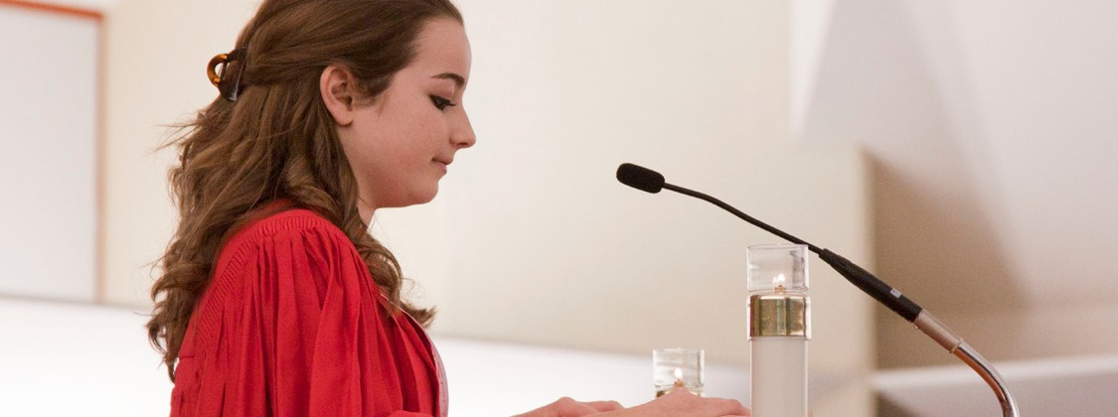International Catholic
Stewardship Council
ICSC@catholicstewardship.org
(800) 352-3452

www.catholicstewardship.com

