Word of Life – June 2022

Bulletin Quotes

June 5th  “The Catholic Church has a long history of service to those who are most vulnerable and remains the largest private provider of social services in the United States. Through the sacrificial efforts of faithful Catholics, the Church serves millions through diocesan ministries and agencies, Catholic hospitals and healthcare systems, immigration clinics, shelters, and Catholic schools and parishes. From religious communities to pregnancy care centers, from refugee resettlement services to foster care and adoption agencies, and from maternity homes to parish-based ministries, the Church consistently bears witness in word and deed to the beauty and dignity of every human life—including both mother and child.”  USCCB Committee Chairmen, “Standing with Moms in Need” | 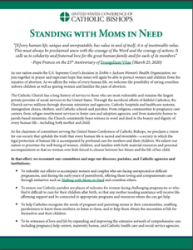  Read Online | Download
June 12th  “In modern times, children in their mothers’ wombs and those approaching the end of their lives are certainly among the ‘least of these’ in our world’s estimation. Practices such as abortion and assisted suicide tragically reject the truth that human life is always to be cherished and defended with loving concern. … Through the intercession of Our Lady of Guadalupe, may Our Lord grant us the grace to truly and courageously live his Gospel of life.”  USCCB Secretariat of Pro-Life Activities, “Live the Gospel of Life”  NABRE © 2010 CCD. Used with permission. | 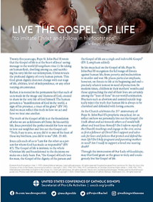  Read | Download
June 19th  “Through our prayers and through the intercession of St. Joseph, patron of fathers, may fathers come to know the irreplaceable role they hold in the lives of their children, and the responsibility they share in welcoming God’s gift of new life!”  Most Reverend Shelton J. Fabre, Bishop of Houma-Thibodaux  “Fathers’ Irreplaceable Role in Welcoming Life” | 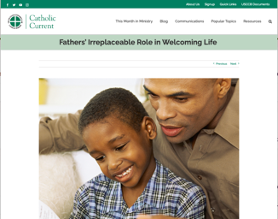  Read Online
June 26th  “O God our Creator… we ask you to bless us in our vigilance for the gift of religious liberty. Give us the strength of mind and heart to readily defend our freedoms when they are threatened; give us courage in making our voices heard on behalf of the rights of your Church and the freedom of conscience of all people of faith.”  USCCB  “Prayer for the Protection of Religious Liberty” | 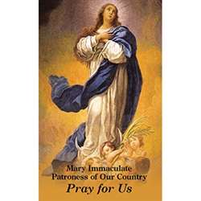  Download

Word of Life – June 2022

Bulletin Art
You are welcome to use these, provided they are not altered in any way, other than the size. Thank you!

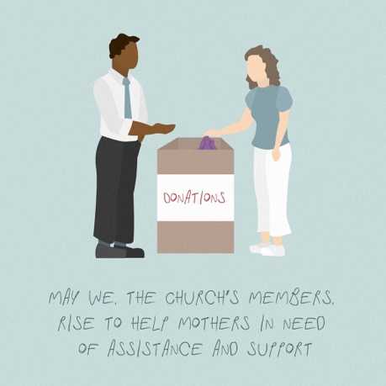
Sunday, June 5th, 2022

Download Image: English
(Other graphics are available here.)

Sunday, June 12th, 2022
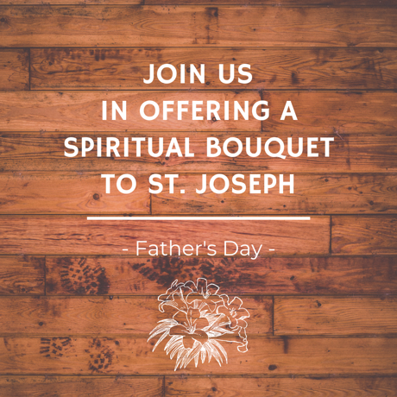
Download Image (Other graphics are available on the same webpages.): English | Spanish

Sunday, June 19th, 2022

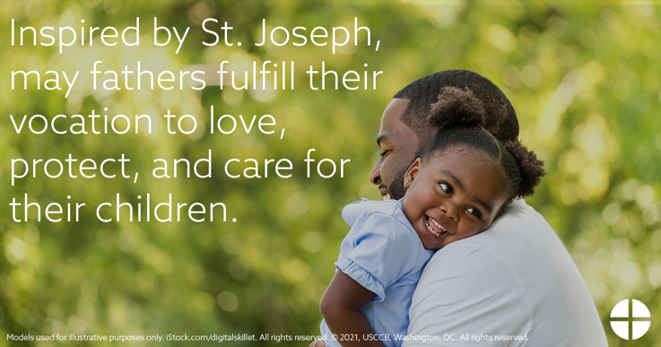
Download Image: English | Spanish

