Word of Life: June 2022
Recommended dates are provided, but you are welcome to use these materials at any time!
Featured this Month…

Special Edition: Dobbs Parish Leader Kit
This Dobbs parish leader kit is a special edition of the Word of Life. It is not month-specific and is dedicated to providing resources to use leading up to and after the Dobbs decision (which is expected by the end of June).

Other materials are also available to assist your efforts at prayfordobbs.com.

Father’s Day Action Guide
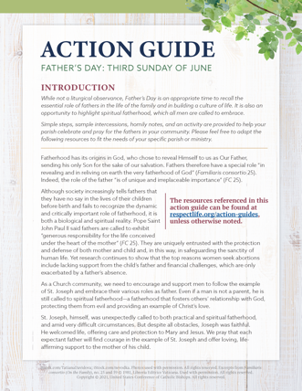
June 19, 2022
Religious Freedom Week: Life and Dignity for All
June 22-29, 2022
Simple steps, sample intercessions, homily considerations, and an activity are provided in the Father’s Day Action Guide to help your parish honor fathers and highlight their importance in building a culture of life.

A previously recorded webinar explains the resources available. Please feel free to adapt the resources to fit the needs of your specific parish or ministry.
- Webinar Recording
- Action Guide (English | Spanish)
- Supplemental Resources (listed under Father’s Day section on this page)
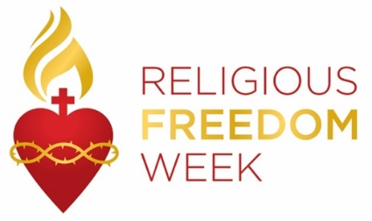
Religious Freedom Week 2022: Life and Dignity for All takes place June 22–29. The Week begins with the Feast of Sts. John Fisher and Thomas More, ends with the Solemnity of Sts. Peter and Paul, and includes the Feast of the Nativity of St. John the Baptist. Many resources are available to help the faithful pray, reflect, and take action on religious liberty, both here in this country and abroad. Resources, including graphics, lectionary notes, bulletin inserts, and daily prayers and reflections are available at usccb.org/ReligiousFreedomWeek.

