**Word of Life: March 2022**

*Recommended dates are provided, but you are welcome to use these materials at any time!*

**Featured this Month…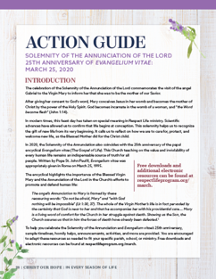Solemnity of the Annunciation of the Lord: March 25, 2022**

In March, the Church celebrates the Solemnity of the Annunciation of the Lord. This feast day helps us to recognize the gift of new life from its very beginning. Our [**March Action Guide**](https://www.usccb.org/resources/respect-life-action-guide-solemnity-annunciation-lord) features a sample timeline, homily helps, announcements, an activity, and more to assist in celebrating this solemnity within your parish community.

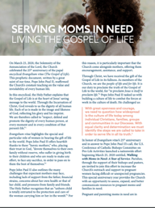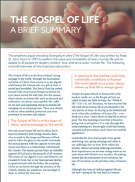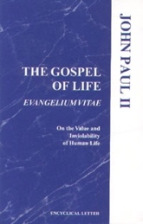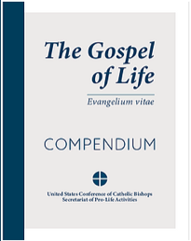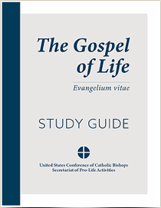

**Anniversary of *Evangelium vitae*: March 25, 2022**

March 25th also marks the anniversary of the papal encyclical *[Evangelium vitae](http://w2.vatican.va/content/john-paul-ii/en/encyclicals/documents/hf_jp-ii_enc_25031995_evangelium-vitae.html)* (*The Gospel of Life*). Several resources are available to help you observe this anniversary in your parish, including the [*The Gospel of Life: Compendium*](https://www.usccb.org/resources/gospel-life-compendium) and [*Study Guide*](https://www.usccb.org/resources/gospel-life-study-guide). Additional resources including bulletin inserts and graphics are available at [respectlife.org/gospel-of-life](https://www.respectlife.org/gospel-of-life).

**St. Joseph Adoption Novena: March 10–18**

Leading up to the Solemnity of St. Joseph on March 19, join us in praying the [St. Joseph Adoption Novena](https://www.respectlife.org/adoption-novena). Invoking the intercession of St. Joseph, foster father of Jesus, we will pray the Lord blesses all who travel upon the path of adoption. Additional [resources](https://www.respectlife.org/adoption-novena-resources) are available.

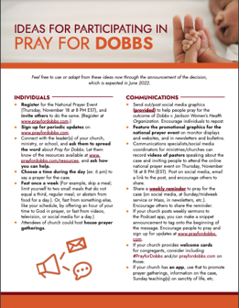**Pray for Dobbs**

Join Catholic, Orthodox, and Protestant Christians uniting in prayer for a just decision in *Dobbs v. Jackson Women’s Health Organization*. Learn more and find resources at [PrayforDobbs.com](https://www.prayfordobbs.com/).