Word of Life – March 2022
Bulletin Quotes
In honor of the anniversary of Evangelium vitae, the bulletin quotes for this month all come from this historic document. Additional artwork is provided for each bulletin quote this month. Please include the following credit with each quote:
Pope Saint John Paul II, Evangelium vitae. © 1995 Libreria Editrice Vaticana. Used with permission.
March 6th  The Gospel of Life is “meant to be a precise and vigorous reaffirmation of the value of human life and its inviolability, and at the same time a pressing appeal addressed to each and every person, in the name of God: respect, protect, love and serve life, every human life! Only in this direction will you find justice, development, true freedom, peace and happiness!” (The Gospel of Life 5) | 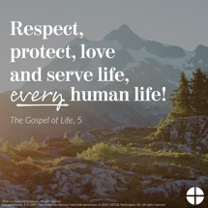  English | Spanish
March 13th  “We are facing an enormous and dramatic clash between good and evil, death and life, the ‘culture of death’ and the ‘culture of life’. We find ourselves not only ‘faced with’ but necessarily ‘in the midst of’ this conflict: we are all involved and we all share in it, with the inescapable responsibility of choosing to be unconditionally pro-life” (The Gospel of Life 28). | 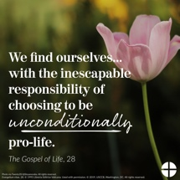  English | Spanish
March 20th  “To celebrate the Gospel of life means to celebrate the God of life, the God who gives life… In every child which is born and in every person who lives or dies we see the image of God’s glory. We celebrate this glory in every human being, a sign of the living God, an icon of Jesus Christ” (The Gospel of Life 84). | 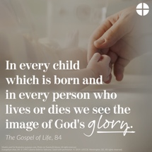  English | Spanish
March 27th  “There is an everyday heroism, made up of gestures of sharing, big or small, which build up an authentic culture of life… Part of this daily heroism is also the silent but effective and eloquent witness of all those ‘brave mothers who devote themselves to their own family without reserve, who suffer in giving birth to their children and who are ready to make any effort, to face any sacrifice, in order to pass on to them the best of themselves’… We thank you, heroic mothers, for your invincible love! We thank you for your intrepid trust in God and in his love. We thank you for the sacrifice of your life” (The Gospel of Life 86). | 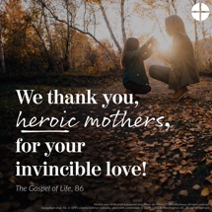  English | Spanish

Word of Life – March 2022

Bulletin Art
You are welcome to use these and other downloadable images from the online Respect Life image gallery, provided they are not altered in any way, other than the size. Thank you!
Sunday, March 6, 2022
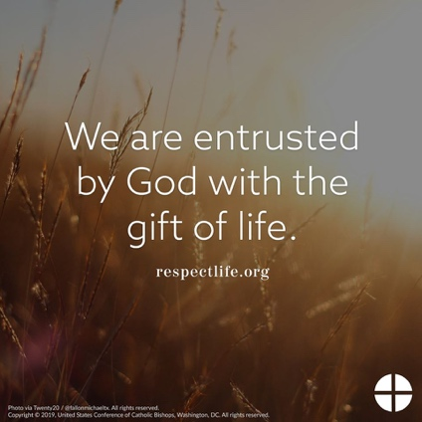
Download: English | Spanish

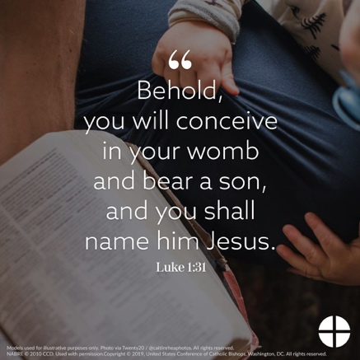
Sunday, March 20, 2022

Download: English | Spanish

Sunday, March 27, 2022
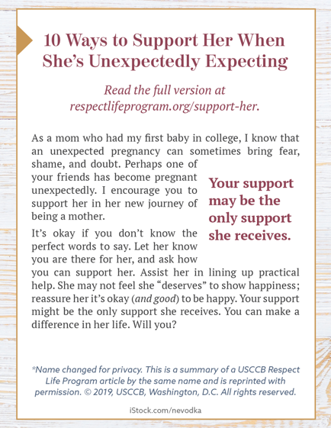
Bulletin Box: English | Spanish

