Word of Life – April 2022
Bulletin Quotes

April 3rd  “Virgin of Guadalupe, Patroness of unborn children, we implore your intercession for every child at risk of abortion. … Guide our public officials  to defend each and every human life through just laws. Inspire us all to bring our faith into public life, to speak for those who have no voice. We ask this in the name of your Son, Jesus Christ, who is Love and Mercy itself. Amen.”  A Prayer to Our Lady of Guadalupe  USCCB Secretariat of Pro-Life Activities | 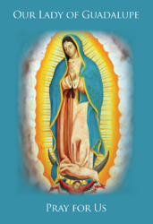  Full Prayer
April 10th  “Despite our best efforts, it can sometimes be difficult to recognize the profound value of human life when we see its full weakness and fragility. Yet, the faithful care of human life until its natural end is entrusted to every person.”  USCCB Secretariat of Pro-Life Activities  “The Witness of the Good Samaritan: Palliative Care and Hospice” | 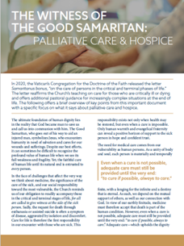  Download
April 17th  “Like us, Christ entered the world through the womb of a woman. He willingly experienced the fullness of human suffering. He breathed his last on the Cross at Calvary in order that He might save us. Therefore, ‘God is the foundation of hope: not any god, but the God who has a human face and who has loved us to the end’ (Spe salvi 31).”  USCCB Secretariat of Pro-Life Activities  “Respect Life Reflection: Christ Our Hope in Every Season of Life” (Citing Pope Benedict XVI, Spe salvi © 2007, Libreria Editrice Vaticana. Used with permission. All rights reserved.) | 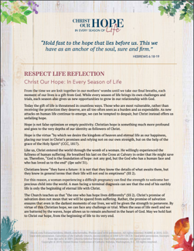  Download
April 24th  If you or someone you know has had an abortion, be assured that it is never too late to seek God’s forgiveness in the Sacrament of Reconciliation. Additionally, other confidential, compassionate help is available. Select “Find Help” from the menu on www.hopeafterabortion.org to find the diocesan Project Rachel Ministry near you.  USCCB Secretariat of Pro-Life Activities  “Bridges of Mercy for Healing after Abortion”  www.usccb.org/bridges-of-mercy | 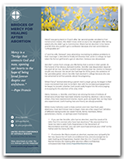  Download

Word of Life – April 2022

Bulletin Art
You are welcome to use these, provided they are not altered in any way, other than the size. Thank you!

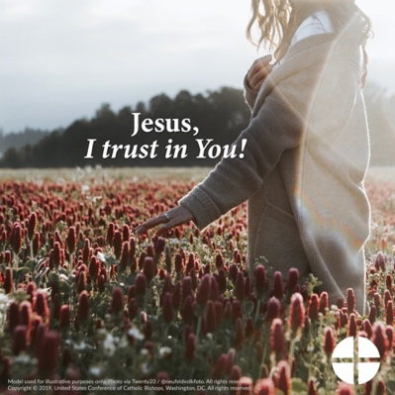

- Download Image: English | Spanish

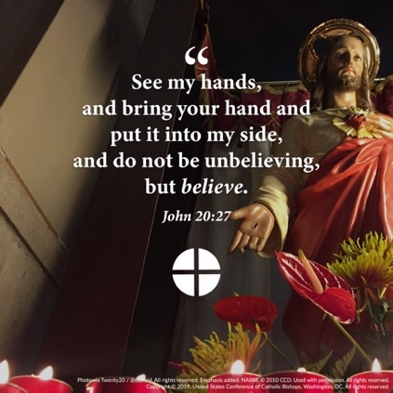
- Download Image: English | Spanish

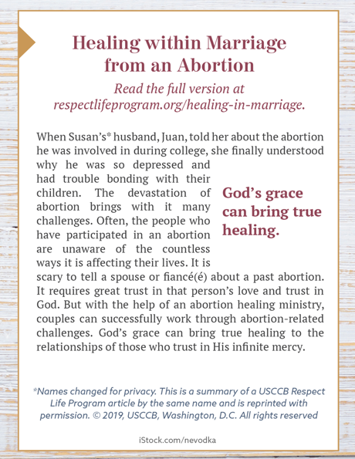
- Download Bulletin Box: English | Spanish

