Word of Life: April 2022
Recommended dates are provided, but you are welcome to use these materials at any time!
Featured this Month…
April 24, 2022: Sunday of Divine Mercy
On the Second Sunday of Easter, the Church celebrates the Sunday of Divine Mercy. It provides an important opportunity to share Christ’s message of mercy, especially with those who suffer because of their participation in an abortion. By the age of 45, as many as 1 in 3 women have had an abortion, and a similar number of men and family members have been involved. Many feel that abortion is “the unforgivable sin.” They need to hear that, through the Sacrament of Reconciliation, God forgives every sin of a repentant heart, even the sin of abortion. In fact, Jesus’ message to St. Faustina is that the greater the sinner, the greater the right to His mercy.
Prayer | Order
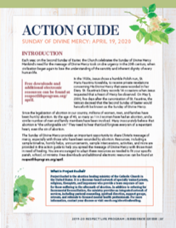
The Action Guide for the Sunday of Divine Mercy includes a sample timeline, simple steps, sample announcements, homily helps, and an activity to help you bring Christ’s message of mercy to your parish community.
Priests and deacons may find these considerations especially helpful when preparing their homilies.
Visit respectlife.org/action-guides and usccb.org/prolife/divine-mercy-sunday for additional resources.

Resources on Abortion Healing
Prayer Guide: Divine Mercy

Bridges of Mercy for Healing After Abortion

Divine Mercy in my Soul

Healing within Marriage from an Abortion

