Word of Life: December 2021
Recommended dates are provided, but you are welcome to use these materials at any time!
Featured this Month…
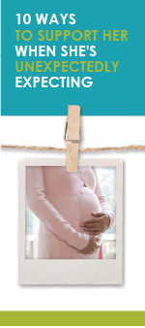
Advent
The season of Advent is a time of preparation that directs our hearts and minds to preparing for the celebration of the Lord’s birth on Christmas and for Christ’s second coming at the end of time. During this time of preparation and expectant waiting, we also remember expectant mothers who are preparing for the birth of their children. This Advent season, consider highlighting the article “10 Ways to Support Her When She’s Unexpectedly Expecting.” (It is available in a variety of formats at the bottom of this webpage.)

Solemnity of the Immaculate Conception of the Blessed Virgin Mary
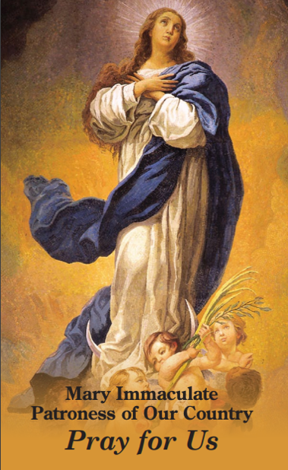
Patronal feast day of the United States of America (December 8, 2021)
On December 8, the Church celebrates the Solemnity of the Immaculate Conception of the Blessed Virgin. (This feast is also a holy day of obligation for dioceses in the United States.) On this feast, we celebrate Mary’s conception free from the stain of Original Sin, and we recognize that Mary’s life began the moment she was conceived in the womb of St. Anne. So, too, does every human life begin at the moment of fertilization, when it is lovingly knit together by God the Father.
The Immaculate Conception is sometimes confused with the Annunciation. This bulletin insert can be used to help differentiate these two important celebrations. On this solemnity, consider praying Pope Francis’ Prayer for the Immaculate Conception: “We are in need of your immaculate gaze, to rediscover the ability to look upon persons and things with respect and awareness.” You can also offer this prayer for religious liberty. The front of the printed prayer card seeks the intercession of Mary Immaculate.

