Word of Life – December 2021

Bulletin Quotes
December 5th  “Jesus calls each of us to ‘care for the other as a person for whom God has made us responsible’ (EV 87). …The encyclical The Gospel of Life recognizes the full range of threats against human life, from poverty and malnutrition to murder and war. Particular emphasis, however, is placed on threats to life at its beginning and end—precisely when it is most in need of protection. In modern times, children in their mothers’ wombs and those approaching the end of their lives are certainly among the ‘least of these’ in our world’s estimation.”  *Excerpt from Evangelium vitae, © 1995, Libreria Editrice Vaticana. Used with permission. All rights reserved.  USCCB Secretariat of Pro-Life Activities  respectlife.org/live-the-gospel-of-life | 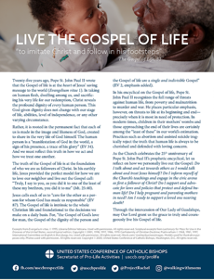  Download
December 12th  “O St. Bakhita, assist all those who are trapped in a state of slavery;  Intercede with God on their behalf so that they will be released from their chains of captivity.  Those whom man enslaves, let God set free.”  USCCB , “Prayer to St. Josephine Bakhita” | 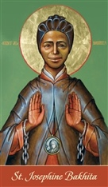  Download
December 19th  “Perhaps one of your friends has become pregnant unexpectedly. As someone who has been there, I encourage you to support your friend in her new journey of being a mother.” Learn ten tips at respectlife.org/support-her.  USCCB Secretariat of Pro-Life Activities  “10 Ways to Support Her When She’s Unexpectedly Expecting” | 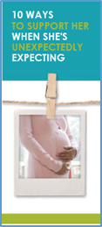  Order | Download
December 26th  “Like every other human family, the Holy Family had to confront real and concrete challenges. Yet, ‘in every situation, Joseph declared his own ‘fiat’’ (PC 3). His ‘yes’ to the Lord meant that regardless of the hardship and personal sacrifice to himself, he consistently chose to put the needs of Mary and Jesus before his own. Joseph’s devotion helps reveal to us our own call to show special care for the lives of those whom God has entrusted to us.”  *Excerpts from Patris corde, © 2020, Libreria Editrice Vaticana. Used with permission. All rights reserved.  USCCB Secretariat of Pro-Life Activities  2021 Respect Life Reflection | 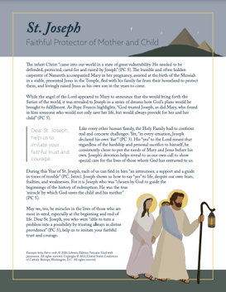  Read | Download

Word of Life - December 2021

Bulletin Art
You are welcome to use these and other downloadable images from the online Respect Life image gallery, provided they are not altered in any way, other than the size. Thank you!
Sunday, December 5th, 2021
Featuring “Live the Gospel of Life”
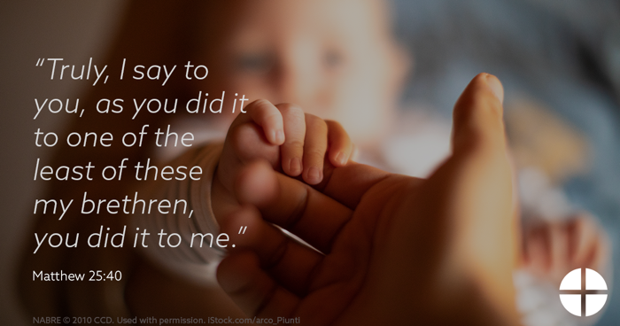
- Graphic
- Bulletin Insert

Sunday, December 19th, 2021
Featuring “10 Ways to Support Her When She’s Unexpectedly Expecting”
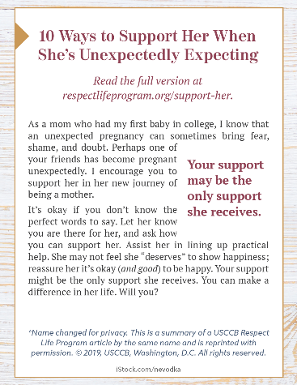
- Bulletin Box

Sunday, December 26th, 2021
Featuring “St. Joseph: Faithful Protector of Mother and Child”
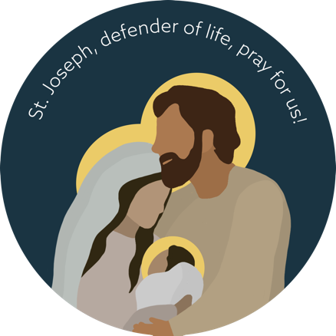
- Graphic
- Reflection

