A STEWARDSHIP MOMENT

Second Sunday of Advent
Weekend of December 4 /5, 2021

In today’s second reading, Saint Paul prays with joy and confidence for his friends in the Christian community
at Philippi. He is encouraged that the community has partnered with him to proclaim the Gospel. He sees Christ’s active presence and plan of salvation at work
in the community. God’s overarching plan is unclear to us. But when we see evidence of God working through others, doesn’t it give us reason to hope that Christ is
alive among us? Does the witness of others help our own prayer lives? Does it inspire us to be partners with others in promoting the Gospel? Food for thought in this second week of Advent.

Third Sunday of Advent
Weekend of December 11/12, 2021

In today’s Gospel we hear the prophet John the Baptist being asked an insightful stewardship question: “What should we do?” Each group wants to know the appropriate response to John’s call; each reply points to how they should treat others. John does not simply say, “Be
baptized.” Rather, he points them to their jobs and personal relationships. John’s message is simple: judgment is near, and repentance includes treating others well. We should be willing to share what we have with those in need. To listen to John the Baptist is to be called to account. Do I give only of my excess, or am I the good steward who is willing to make daily sacrifices in order to help others?

Fourth Sunday of Advent
Weekend of December 18/19, 2021

As we draw close to the great Feast of the Nativity, we hear the bold stewardship proclamation twice in today’s second reading from the Letter to the Hebrews: “Behold, I come to do your will, O God!” Who is this Jesus? Who are we that
we should follow him? Many want him as a friend, a guide, a king, an advocate. We long to see the face of God. Jesus reveals the nature of God, the servant sent to give us new life in Him. Take time to ponder: Do we have the courage
to follow Jesus? To show others the face of God? To say to the Lord: “Behold, I come to do your will?”

The Nativity of the Lord (Christmas Day) Saturday, December 25, 2021
In today’s Christmas Mass at dawn we hear from the Gospel reading that God has entered quietly into the world. Not into the great city of Jerusalem, but into a small village about five miles south. Not into a noble family, but to an outcast couple keeping the newborn in a manger.
Not announced by royal edicts, but to common shepherds, the first human heralds of Christ’s birth. As Christian stewards we simply allow Christ to live in us no matter what our circumstances happen to be. We allow Christ to share his love with us and reflect that love out to others.
We now are the heralds of Christ’s Incarnation. What an unimaginable gift from a generous Lord. Good stewards rejoice in this gift and give glory to God.

Feast of the Holy Family of Jesus, Mary and Joseph
Sunday, December 26, 2021

The ultimate aim of Saint Paul’s Letter to the Colossians
is to teach the community how to deepen its relationship with Christ Jesus. His list of virtues summarizes the
ideals of communal stewardship: compassion, kindness, humility, gentleness and patience. For Paul, practicing these virtues opens our hearts to Christ as individuals and as a worshipping community. This is how the Christian community ought to live. This is how its members should behave in their dealings with others, particularly with fellow believers. As we approach a new year, how might we embrace one of these virtues more fully in order to deepen our relationship with Jesus?

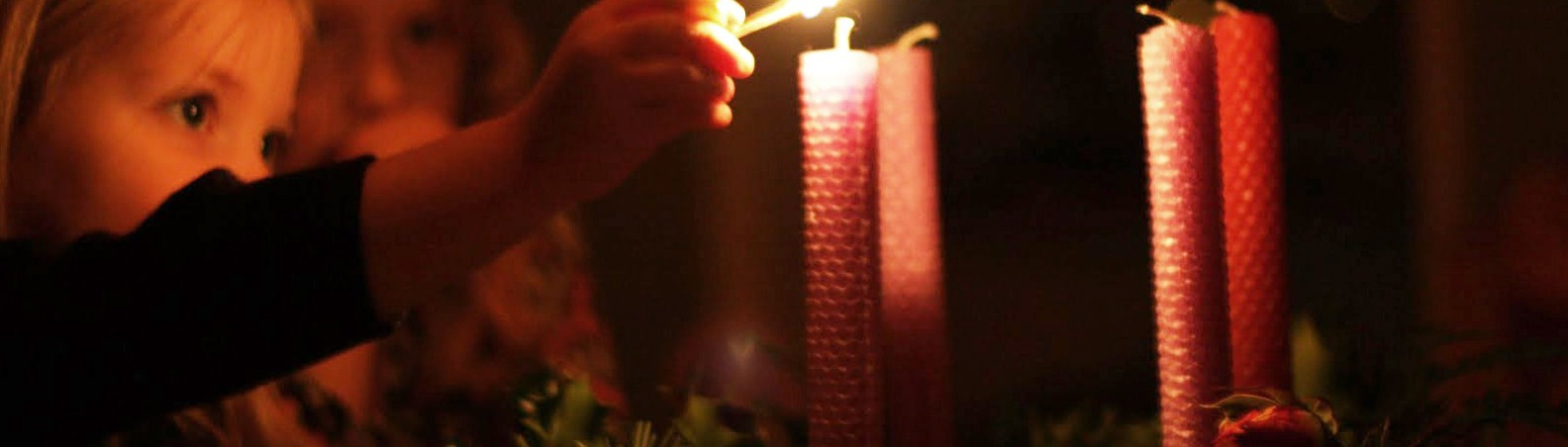International Catholic
Stewardship Council
ICSC@catholicstewardship.org
(800) 352-3452

www.catholicstewardship.com

