Word of Life – November 2021
Bulletin Quotes
November 7th  “We know earthly death is not the end, but rather the door through which we must pass to gain eternal life. Because of our belief and hope in the Resurrection, we can face death not with fear, but with preparation… We prepare for eternal life by choosing to love and follow God now, in our daily lives and decisions.”  USCCB Secretariat of Pro-Life Activities,  “Catholic Considerations for Our Earthly Passing”  respectlife.org/end-of-life-considerations | Order | Download  Online
November 14th  “We can’t imagine loving a child whom we conceived more than we love Andrew. It is amazing how he fits our personalities so well… Adopting Andrew has made us more aware of God’s power and of his love for us. We realize that he always has a perfect plan for our lives.”  USCCB Secretariat of Pro-Life Activities,  “An Adoption Love Story” (respectlife.org/adoption-love-story) | 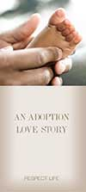  Order | Download  Online
November 21st  “The right to religious freedom has its foundation in the very dignity of the human person.”  Pope Paul VI, Dignitatis humanae (Declaration on Religious Freedom), 2.  © 1965 Libreria Editrice Vaticana. Used with permission. All rights reserved. | Read Online
November 28th  “Having received the gift of the Gospel of Life, we are the people of life and a people for life. It is our duty to proclaim the Gospel of Life to the world. To proclaim Jesus is to proclaim life itself. Gratitude and joy at the incomparable dignity of the human person impel us to bring the Gospel of life to the hearts of all people and make it penetrate every part of society.”  USCCB Secretariat of Pro-Life Activities  “The Gospel of Life: A Brief Summary”  respectlife.org/gospel-of-life-summary | Download | Read Online  Online

Word of Life - November 2021

Bulletin Art
You are welcome to use these and other downloadable images from the online Respect Life image gallery, provided they are not altered in any way, other than the size. Thank you!

Sunday, November 14th, 2021
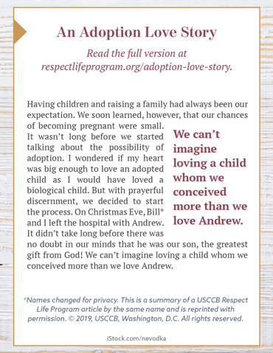
- Image (Color): English | Spanish
- Image (Grayscale): English | Spanish
- Quote Source: An Adoption Love Story (See bottom of the webpage for additional formats.)

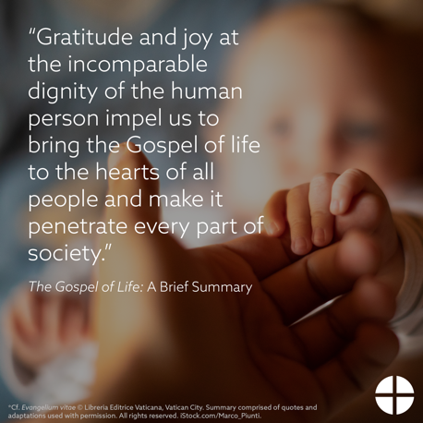
Sunday, November 28th, 2021
Online Article: The Gospel of Life: A Brief Summary
Image, Bulletin Insert PDF, and Word Doc
https://www.usccb.org/resources/gospel-life-brief-summary

