Word of Life: November 2021
Recommended dates are provided, but you are welcome to use these materials at any time!
Featured this Month…
- November is National Adoption Awareness Month!
This occasion is an opportunity to highlight the gift of adoption. Resources are available to assist you in supporting and praying for all whose lives are touched by adoption:
Novena to St. Joseph:
For Those on the Path of Adoption
Accompanying Expectant
Mothers Considering Adoption
An Adoption
Love Story
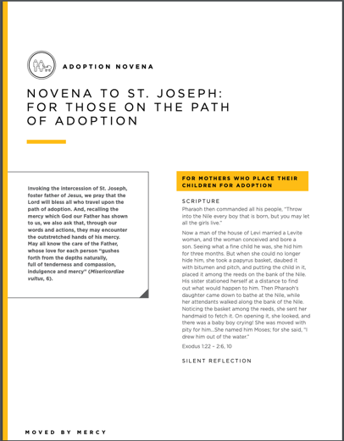
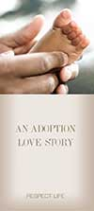

Walking with Moms Prayer Guide
November 2021
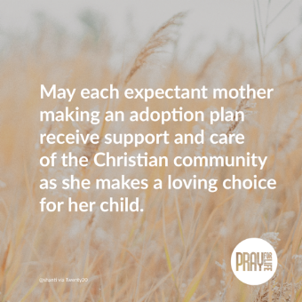
Sample Announcement
Find prayer guides for the whole year at walkingwithmoms.com/pray-for-moms!
Image and Prayer Guide (print version)
https://www.usccb.org/resources/wwmin-prayer-guide-11

The Solemnity of Our Lord Jesus Christ, King of the Universe
November 21, 2021
Resources are being made available to help educate the faithful about the Solemnity of Christ the King and its connection to religious liberty.
21

