Parish Religious Education Catechist

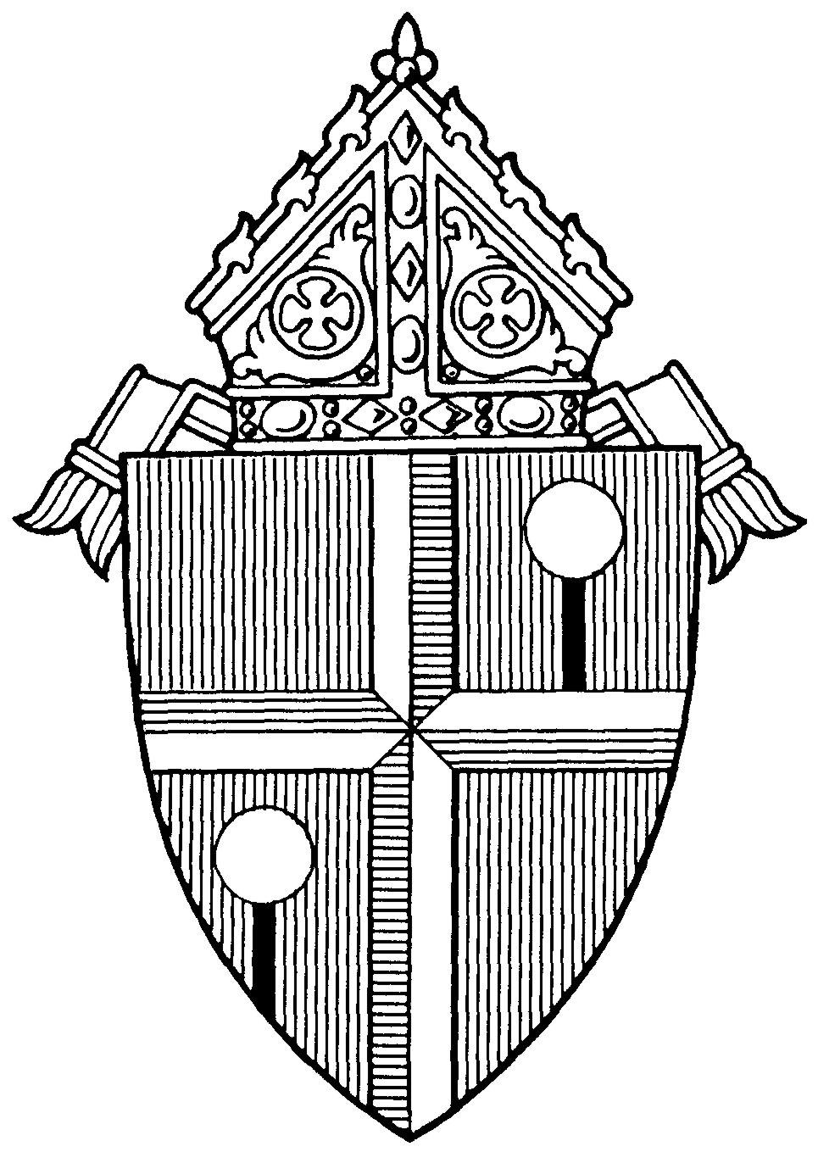

Lay Ecclesial Ministry
Formation and Certification

Diocese of Honolulu

LAY ECCLESIAL MINISTRY FORMATION AND CERTIFICATION
OVERVIEW

Go, therefore, and make disciples of all nations, baptizing them in the name of the Father, and of the Son, and of the Holy Spirit, teaching them to observe all that I have commanded you. And behold, I am with you always, until the end of the age. (Mt. 29: 19 – 20)

The Lay Ecclesial Ministry Formation and Certification process for catechists provides basic and advanced workshops designed to help catechists form believers for an integral Christian life as outlined by the Directory for Catechesis (2020): 1) leading to knowledge of faith; 2) initiating into the celebration of the mystery; 3) forming for life in Christ; 4) teaching prayer; 5) introduction to community life.

This booklet outlines the required workshops for parish religious education catechists.

“It is clear that, in order to present the Catholic faith in its fullness and in a way that is attractive, those who catechize need preparation and ongoing formation specific to the conditions of those to whom they proclaim the Gospel message.” (NDC #54-A.8)
Personal Qualities of a Catechist

The Church calls forth exemplary followers of Christ who have a living, conscious, active participation in the sacramental life of the Church. Personal qualities of catechists should include:

- faith that manifests itself in their piety and daily life;

- love for the Church; apostolic spirit and missionary zeal;

- love for their brothers and sisters and a desire to give generous service;

- a willingness to continue their own religious education and formation;

- the human, moral, and technical qualities necessary for the ministry of a catechist such as dynamism and good relationships with others;

- respect for the diversity of cultures;

- an ability to appreciate different stages of individual growth and development;

- an ability to communicate effectively with the persons to be catechized.

These general qualities will have to be made more specific for local conditions and applied to the particular circumstances in each area [see NDC, p. 236].

Approved Workshop Options:

Diocesan-approved workshops are available through:

- Franciscan University Catechetical Institute:
www.franciscanathome.com/diocese-honolulu

- Catechetical Foundation workshops offered through the Offices of Religious Education and for Youth and Young Adult Ministries.

- Catechesis of the Good Shepherd (through certified CGS international formation leaders)

- Parish and diocesan sponsored workshops

- Accredited college or university

All workshops are to be completed within three years from the start of your catechetical ministry.

Using this Tracking Booklet:

Individuals may use this booklet to help keep track of workshops.

Once all workshops are finished, inform your Ministry Coordinator who will then report completions to the diocesan Office of Religious Education.

Your Name: _______________________________________________

Parish: ____________________________________________________

Date of Completion: _______________

REQUIRED WORKSHOPS
TITLE | ONLINE WORKSHOPS FOUND ON  “CATECHIST TRACK”  www.franciscanathome.com/diocese-honolulu
Sacred Scripture | Scripture: The Heart of Catechesis  AND  Sacred Scripture: The Big Picture
Christian Prayer | Prayer: Introduction to the Spiritual Life of the Catechist
Profession of Faith | The Deposit of Faith: Introduction to the Catechism AND  The Trinity
Life in Christ | Jesus: The Christocentricity of Catechesis  AND  Christ, His Person and Works
Celebration of the Christian Mystery | The Essential Link Between Liturgy & Catechesis
Characteristics of Human Development | Philosophical Foundations of Catechetics
Roles of the Catechist | The Vocation of the Catechist
Methods for Teaching Children | The Ecclesial Method  AND  Child Catechetical Methodologies & Learning Styles

REQUIRED WORKSHOP COMPLETIONS

Sacred Scripture |  | Date Completed:
Check One:
Franciscan At Home:
Scripture: The Heart of Catechesis AND
Sacred Scripture: The Big Picture
Catechesis of the Good Shepherd: Part One Training,
All Levels
 | Faith Formation Conference: (session title)
 | Other:
Pastor or Parish Catechetical Leader Signature
_______________________________

Print Name: Date:

Christian Prayer |  | Date Completed:
Check One:
Franciscan At Home:
Introduction to the Spiritual Life of the Catechist
Catechesis of the Good Shepherd: Part One Training,
All Levels
 | Faith Formation Conference: (session title)
 | Other:
Pastor or Parish Catechetical Leader Signature
_______________________________

Print Name: Date:

Profession of Faith |  | Date Completed:
Check One:
Franciscan At Home:
The Deposit of Faith: Introduction to the Catechism AND
The Trinity
 | Catechesis of the Good Shepherd: Part One Training, All Levels
 | Faith Formation Conference: (session title)
 | Other:
Pastor or Parish Catechetical Leader Signature
_______________________________

Print Name: Date:
Life in Christ |  | Date Completed:
Check One:
Franciscan At Home:
Jesus: The Christocentricity of Catechesis
AND
Christ, His Person and Works
 | Catechesis of the Good Shepherd: Part One Training, All Levels
 | Faith Formation Conference: (session title)
 | Other:
Pastor or Parish Catechetical Leader Signature
_______________________________

Print Name: Date:

Celebration of the Christian Mystery |  | Date Completed:
Check One:
Franciscan At Home:
The Essential Link Between Liturgy & Catechesis
 | Catechesis of the Good Shepherd: Part One Training, All Levels
 | Faith Formation Conference: (session title)
 | Other:
Pastor or Parish Catechetical Leader Signature
_______________________________

Print Name: Date:

Characteristics of Human Development |  | Date Completed:
Check One:
Franciscan At Home:
Philosophical Foundations of Catechetics
 | Catechesis of the Good Shepherd: Part One Training, All Levels
 | Faith Formation Conference: (session title)
 | Other:
Pastor or Parish Catechetical Leader Signature
_______________________________

Print Name: Date:

Roles of the Catechist |  | Date Completed:
Check One:
Franciscan At Home:
The Vocation of the Catechist
 | Catechesis of the Good Shepherd: Part One Training, All Levels
 | Faith Formation Conference: (session title)
 | Other:
Pastor or Parish Catechetical Leader Signature
_______________________________

Print Name: Date:

Methods for Teaching Children |  | Date Completed:
Check One:
Franciscan At Home:
The Ecclesial Method AND
Child Catechetical Methodologies & Learning Styles
 | Catechesis of the Good Shepherd: Part One Training, All Levels
 | Faith Formation Conference: (session title)
 | Other:
Pastor or Parish Catechetical Leader Signature
_______________________________

Print Name: Date:

EQUIVALENCIES

Workshops taken in the past toward certification may be honored. However, catechists are encouraged to take workshops on similar topics (Sacred Scripture, Liturgy & Sacraments, Methodology, etc.) to deepen their spirituality and catechetical skills.

ONGOING FORMATION

Faith formation is a life-long process that requires continual participation and engagement. Ongoing formation may include additional workshops, personal reading, Catholic retreats, pilgrimages, college courses in theology, attending a variety of local and national training sessions or conferences, etc.

MASTER CATECHIST CERTIFICATION

Catechists, particularly those in positions of leadership, are encouraged to earn a Master Catechist Certification by completing the Advanced Level courses offered on Franciscan At Home www.franciscanathome.com/diocese-honolulu

Or through the Certificate of Catechesis through the University of Dayton, Virtual Learning Community for Faith Formation https://vlcff.udayton.edu

Catechists holding a master’s degree or its equivalent in theology, religious studies, or related fields may be recognized as a Master Catechist. Contact the Office of Religious Education for details.

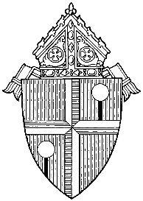

Diocese of Honolulu
Office of Faith Formation and Religious Education
St. Stephen Diocesan Center
6301 Pali Highway
Kaneohe, Hawaii 96744
www.catholichawaii.org/catechist
(808) 203-6747 office
(808) 261-7022 fax

