Word of Life: August 2021
Recommended dates are provided, but you are welcome to use these materials at any time!
Featured this Month…
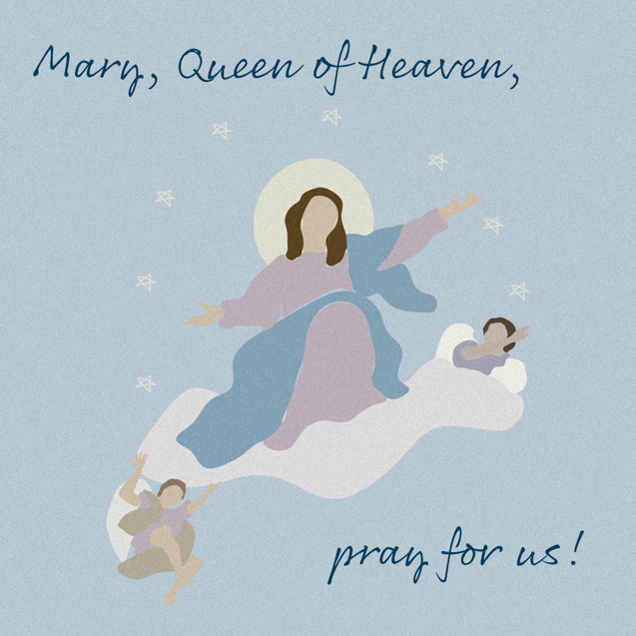
Reflection on the Solemnity of the Assumption of the Blessed Virgin Mary
August 15, 2021
The Solemnity of the Assumption celebrates the Blessed Mother’s entrance into heavenly glory. The Catechism explains that Mary “was taken up body and soul into the glory of heaven, where she already shares in the glory of her Son’s Resurrection, anticipating the resurrection of all members of his Body” (CCC, 974).
Mary’s Assumption into heaven reminds us that life on earth is a pilgrimage to our ultimate destination. We prepare in hope for our own passage into eternal life by the choices we make today. When we choose to love and follow God in our daily lives, we strengthen our relationship with Him, and this relationship is the true meaning of heaven: “To live in heaven is ‘to be with Christ’” (CCC, 1025 citing St. Ambrose, In Luc.,10,121:PL 15 1834A.).
Download
We can see how, throughout her life, the Blessed Mother continually chose to go deeper into her relationship with God. She modeled how to value and respect His precious gift of human life, from the moment of conception to its natural end. In the Annunciation, through her “yes,” Mary witnessed to the undeniable humanity of unborn children as she conceived and carried the Christ child in her womb. After the Annunciation, having learned that her cousin Elizabeth was with child, she went in haste to her aid.
Need a photo to go with this reflection?
Many works of art are believed to be in the common domain and are available to download from museum websites.

The Assumption of the Virgin, Bergognone
Credit: Bergognone, “The Assumption of the Virgin,” Oil and Gold on Wood, ca. 1453-1523, Fletcher Fund, 1926, courtesy of The Metropolitan Museum of Art, New York, NY.
The Assumption, Laurent de La Hyre
Credit: De La Hyre, Laurent, “The Assumption,” oil on canvas, ca. 1653, The Ciechanowiecki Collection, Gift of The Ahmanson Foundation, courtesy of the Los Angeles County Museum of Art.

Our Blessed Mother shows us how the way we live today can prepare us, in hope, to also enter into heavenly glory at the end of our lives. Are we open to God’s precious gift of new life? How do we support expectant mothers and parents of young children? Do we prioritize showing our love and care for loved ones who are ill or aging?
Holy Mary, Mother of God, pray for us sinners, now and at the hour of our death. Amen.

Catechism of the Catholic Church, second edition © 2000 LEV-USCCB. Used with permission. All rights reserved.

