Word of Life – August 2021
Bulletin Quotes
August 1st  “We thank you, heroic mothers, for your invincible love! We thank you for your intrepid trust in God and in his love. We thank you for the sacrifice of your life” (EV 86).  Pope Saint John Paul II, Evangelium vitae © 1995, Libreria Editrice Vaticana.  Used with permission. All rights reserved. | 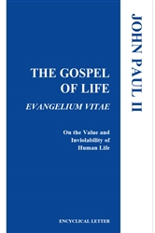  Order | Read Online
August 8th  “Although we may feel unsure how best to comfort those who mourn, we must stand with them in their time of suffering. Miscarriage touches the lives of many people, yet all too often this tragedy remains unaddressed. This lack of response not only often leads to unresolved grief, but also fails to clearly manifest our belief that each person, from conception onward, is precious and unique.”  USCCB Secretariat of Pro-Life Activities  “Solace and Strength in the Sorrow of Miscarriage” | 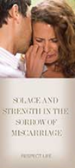  Order | Download
August 15th  “In times of suffering, the human person should be able to experience a solidarity and a love that takes on the suffering, offering a sense of life that extends beyond death… In the family a person can count on strong relationships, valued in themselves apart from their helpfulness or the joy they bring. It is essential that the sick under care do not feel themselves to be a burden, but can sense the intimacy and support of their loved ones” (SB 4-5).  Congregation for the Doctrine of the Faith, Samaritanus bonus: On the Care of Persons in the Critical and Terminal Phases of Life © 2020, Libreria Editrice Vaticana. Used with permission. All rights reserved. | 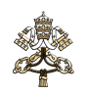  Read Online
August 22nd  “God’s love—individual, real, unchanging—is the true source of our worth, identity, and dignity. It really is not a question of who we are, but rather whose we are. Because his love will never change, nothing can reduce our God-given dignity, and nothing can diminish the immeasurable worth of our lives.”  USCCB Secretariat of Pro-Life Activities  “How to Build a Culture of Life” | 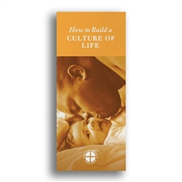  Order | Download
August 29th  “No sin or crime is greater than God’s mercy. The sacrifice of the Cross reveals that Christ’s greatest desire is to forgive those with a repentant heart.”  USCCB Secretariat of Pro-Life Activities  “Death Penalty: Catholic Q&A” | 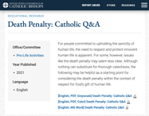  Download

Word of Life – August 2021

Bulletin Art
You are welcome to use these, provided they are not altered in any way, other than the size. Thank you!

Sunday, August 1, 2021
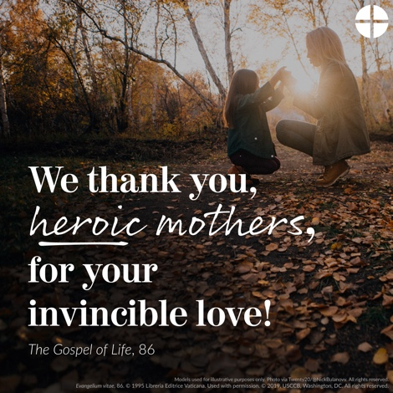
- Download Image: English | Spanish

Sunday, August 15, 2021
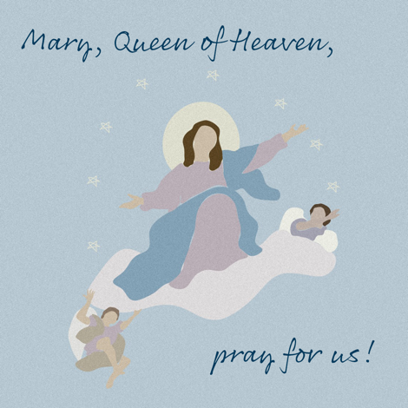
- Download Image: English | Spanish

Sunday, August 22, 2021
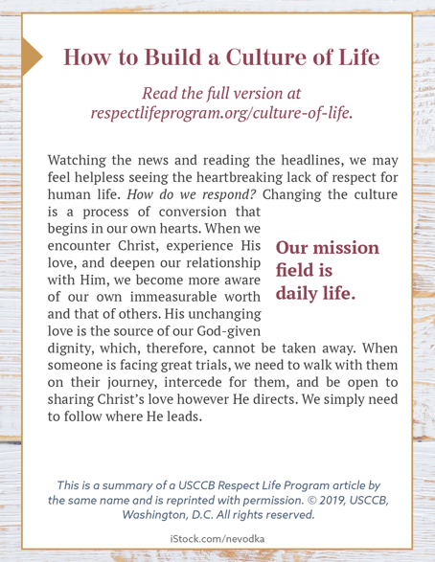
How to Build a Culture of Life

- Online: English | Spanish
- ¼ Page “Bulletin Box” Image: English | Spanish
- Full-Length Bulletin Insert (print format): English | Spanish

