A STEWARDSHIP MOMENT

Eighteenth Sunday in Ordinary Time
Weekend of July 31, August 1, 2021

In today’s Gospel we hear Jesus proclaiming that he is “the bread of life.” He then offers an invitation to come to him. For us, the invitation is to live the Eucharistic life in Christ. What does it mean for our parish family to live together in
the Eucharist? What does it mean for us to share the Eucharist together, to participate in the “bread of life” together? Does
it mean we love each other, support our community of faith, work together? Do we carry each other’s burdens? Celebrate our joys? What are the practical implications of being good stewards of our Eucharistic life together?

Nineteenth Sunday in Ordinary Time
Weekend of August 7-8, 2021

The Letter to the Ephesians urges us to be mindful that part of our life together in the Eucharist means being kind to
one another, compassionate and forgiving, just as Christ has forgiven us. What can we do this week to show our kindness, compassion and forgiving attitude toward others in our family of faith? How can we be even better stewards of our faith community as, what St. Paul refers to as “Imitators of God?”

The Assumption of the Blessed Virgin Mary
Weekend of August 14-15, 2021

In today’s Gospel we hear Mary’s cousin, Elizabeth, bestow the gift of two blessings on Mary when she greets her. Elizabeth blesses Mary not only because she believes that Mary is the mother of the Lord, but also because she recognizes that Mary has complete faith in God’s promise. When Elizabeth prophetically pronounces Mary “blessed
… among women” and proclaims that the fruit of Mary’s womb is blessed, she uses the same term that Jesus uses to bless people in the Beatitudes. Good stewards recognize the Spirit-driven love and courage that inspired Elizabeth’s
hospitality toward a young, unmarried, pregnant woman and the honor Elizabeth bestowed upon Mary who would ordinarily be shamed for bearing this child. In what ways can we extend the blessings we receive in the Eucharistic celebration to others in order to honor them and offer them God’s hospitality?

Twenty-first Sunday in Ordinary Time
Weekend of August 21-22, 2021

In today’s Gospel, we hear that a number of Jesus’ followers left him because his message was too difficult for them to accept. In essence, they did not believe in him. He then asked the Twelve if they wished to leave as well. Peter responds by making a profound profession of faith in Jesus as Lord and Savior. The Twelve made a choice and stood
by their choice, remaining loyal to their commitment to Jesus. A good question for our reflection might be this: Are we satisfied with the stewardship we exercise over our baptismal commitment? Are we just “along for the ride?” Are we keeping Christ in front of us as we make decisions about our daily activities, our relationships, our parish, issues in
the workplace, issues such as peace and justice? What is the quality of our stewardship?

Twenty-second Sunday in Ordinary Time
Weekend 28-29, 2021

In the reading from the letter of St. James we are urged to be
“doers” of the Gospel, not just listeners. Being a “steward” of God’s Word is a matter of listening to the Good News, embracing the Good News and putting the Good News into action in our day-to-day lives. And whenever we are uncertain as to what decisions to make or actions to take as good stewards of the Gospel, St. James reminds us: We
can never go wrong if we resist popular values that are not compatible with the Gospel, and we come to the aid of those who are burdened, distressed and poor.

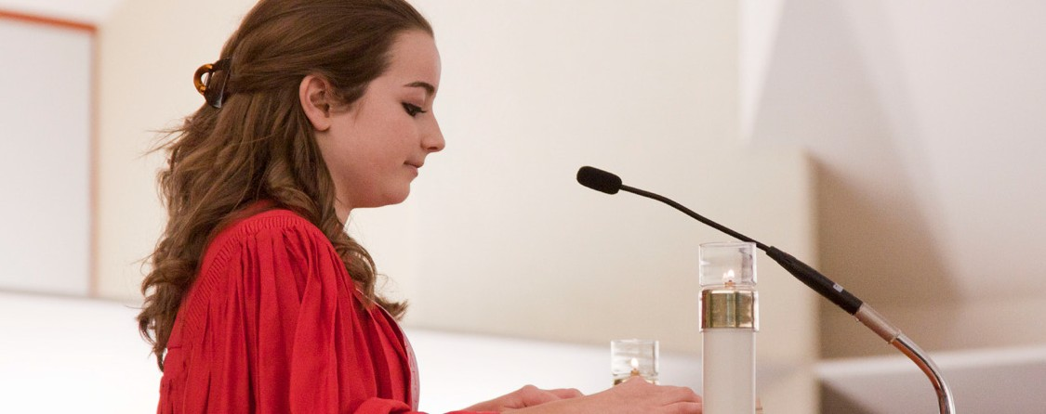International Catholic
Stewardship Council
ICSC@catholicstewardship.org
(800) 352-3452

www.catholicstewardship.com

