Word of Life: July 2021
Recommended dates are provided, but you are welcome to use these materials at any time!

Featured this Month
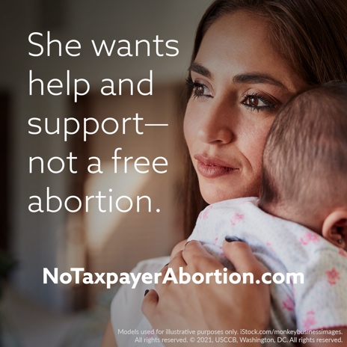
Stop Taxpayer-Funded Abortion: First half of July
It is critically important for a massive number of people to contact Congress against taxpayer-funded abortion before it votes on it during the second half of July.
Please consider using these graphics and sample text in your bulletins, newsletters, etc. to encourage people to contact their Members of Congress.
More tools: www.respectlife.org/no-taxpayer-abortion

National NFP Awareness Week: July 25-31, 2021
The dates of National Natural Family Planning Awareness Week highlight the anniversary of the papal encyclical Humanae vitae (July 25), which articulates Catholic beliefs about human sexuality, married love, and responsible parenthood. Couples’ stories, sample intercessions, homily notes, graphics, and more can be found online.
Poster
PDF: English | Spanish JPG: English | Spanish
Feast of Saints Joachim and Anne: July 26, 2021
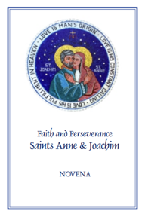
The Feast of Saints Anne and Joachim, parents of the Blessed Virgin Mary, is celebrated on June 26. They are powerful intercessors for all married couples, expectant mothers, and married couples who are having difficulty conceiving, as well as those who are aging. Copies of the “Faith and Perseverance” Novena to Saints Anne and Joachim are available for download or purchase. You can pray the novena from July 17-25 in preparation for their feast day.
Download: English | Spanish

