Word of Life – July 2021

Bulletin Quotes
July 4th  “O God our creator… through the power and working of your Holy Spirit, you call us to live out our faith in the midst of the world, bringing the light and the saving truth of the Gospel to every corner of society.”  United States Conference of Catholic Bishops  “Prayer for Religious Liberty” | 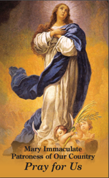  Order | Download
July 11th  “Adopting Andrew has made us more aware of God's power and of his love for us. We realize that he always has a perfect plan for our lives.”  Read more at www.bit.ly/AdoptionLoveStory.  USCCB Secretariat of Pro-Life Activities  “An Adoption Love Story” | 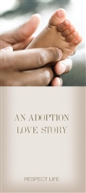  Order | Download
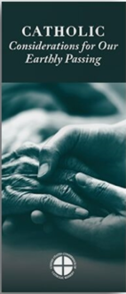
July 18th
“Because of our belief and hope in the Resurrection, we can face death not with fear, but with preparation…. We prepare for eternal life by choosing to love and follow God now, in our daily lives and decisions.” Read more at www.respectlife.org/end-of-life-considerations.
USCCB Secretariat of Pro-Life Activities
“Catholic Considerations for Our Earthly Passing”
Order | Download
July 25th  “Married love differs from any other love in the world. By its nature, the love of husband and wife is so complete, so ordered to a lifetime of communion with God and each other, that it is open to creating a new human being they will love and care for together. … That power to create a new life with God is at the heart of what spouses share with each other.”  United States Conference of Catholic Bishops  “Married Love and the Gift of Life” | Order | Download

Word of Life - July 2021

Bulletin Art
You are welcome to use these, provided they are not altered in any way, other than the size. Thank you!

Sunday, July 11th, 2021
It is critically important for a massive number of people to contact Congress against taxpayer-funded abortion before it votes on it during the second half of July.
Please consider using these graphics and sample text in your bulletins, newsletters, etc. to encourage people to contact their Members of Congress.
More resources: www.respectlife.org/no-taxpayer-abortion

Sunday, July 25th, 2021

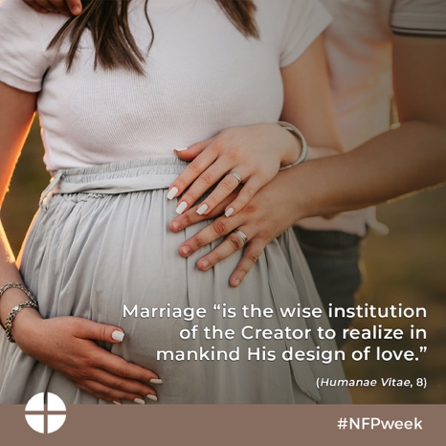
Graphic: English | Spanish

