A STEWARDSHIP MOMENT

Fourteenth Sunday in Ordinary Time
Weekend of July 3/4, 2021

Today’s Gospel reveals Jesus being amazed that the people in his hometown of Nazareth do not accept his teaching and ministry; he is amazed at their lack of
faith (Mk 6:6). Good stewards recognize and participate in Christ’s teaching, reconciling and healing presence
in their community. Are we good stewards of our
family of faith? Do we value and support the ministries that take place in Christ’s name? Are we attentive to
the movement of the Holy Spirit in our parish and encourage those who work to enhance our life of faith?

Fifteenth Sunday in Ordinary Time
Weekend of July 10/11, 2021

In his Letter to the Ephesians, Saint Paul teaches that God, the Father, has established a divine plan to bring all of creation to Christ and that He has blessed us with an abundance of divine gifts to help implement that plan. Christian stewards know what their gifts are and remain committed to using them in the service of the Lord. Do we know what our gifts are? Do we believe that God has given us these gifts? Are we committed to using our gifts to serve the Lord?
Sixteenth Sunday in Ordinary Time
Weekend of July 17/18, 2021

The Letter to the Ephesians reminds us that Christ is creating a new world order: one that brings about relationships based on love, peace, reconciliation, hope and unity. As a Eucharistic community, we are stewards of Christ’s new creation. How are we promoting peace and reconciliation? How are we showing love for our neighbors? What are we doing to encourage unity and understanding among those with whom we gather around the Lord’s Table each week?

Seventeenth Sunday in Ordinary Time
Weekend of July 24/25, 2021

The story of the multiplication of the loaves and the fishes is a familiar one, and has many lessons, not least of which is how our willingness to share who we are and what we have. Exercising good stewardship serves to release God’s power and bountifulness on the world and its people. Do we realize that there is enough for all if we are willing to share? Are we aware that God is at work when we share our time, our money and our other resources in His name?

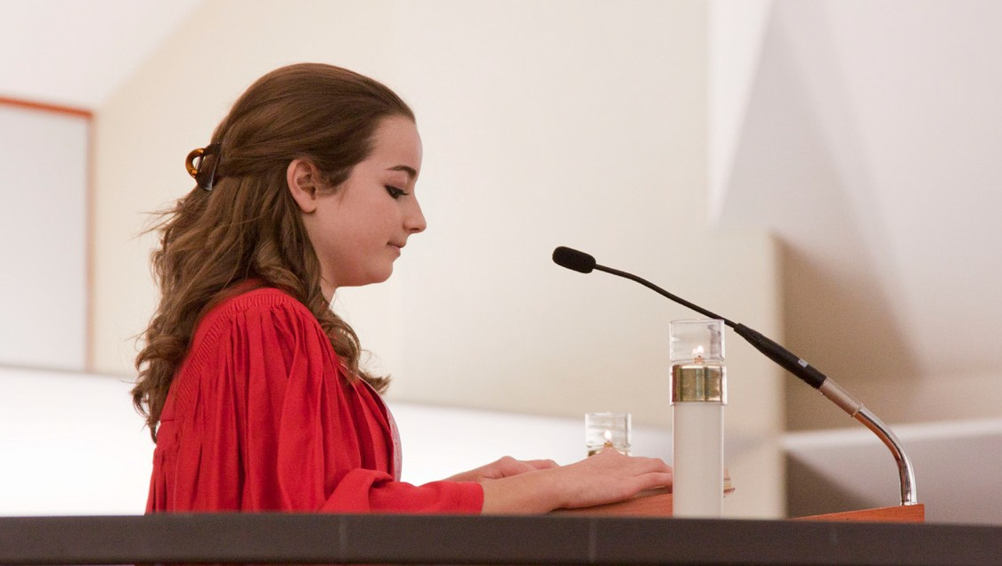International Catholic
Stewardship Council
ICSC@catholicstewardship.org
(800) 352-3452

www.catholicstewardship.com

