Word of Life – April 2021
Bulletin Quotes

April 4th  “Like us, Christ entered the world through the womb of a woman. He willingly experienced the fullness of human suffering. He breathed his last on the Cross at Calvary in order that He might save us. Therefore, ‘God is the foundation of hope: not any god, but the God who has a human face and who has loved us to the end’ (Spe salvi 31).”  USCCB Secretariat of Pro-Life Activities  “Respect Life Reflection: Christ Our Hope in Every Season of Life” (Citing Pope Benedict XVI, Spe salvi © 2007, Libreria Editrice Vaticana. Used with permission. All rights reserved.) | 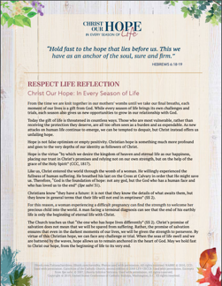  Download
April 11th  If you or someone you know has had an abortion, “be assured that it is never too late to seek God’s forgiveness in the Sacrament of Reconciliation.”* Additionally, other confidential, compassionate help is available. Select “Find Help” from the menu on www.hopeafterabortion.org to find the diocesan Project Rachel Ministry near you.  USCCB Secretariat of Pro-Life Activities  *“Bridges of Mercy for Healing after Abortion”  www.usccb.org/bridges-of-mercy | 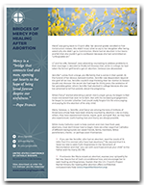  Order | Download
April 18th  “Christ invites us to trust in his invisible grace that prompts us to the generosity of supernatural charity, as we identify with everyone who is ill: ‘Amen, I say to you, whatever you did for one of these least brothers of mine, you did for me’ (Mt 25:40).”  Congregation for the Doctrine of the Faith  “Samaritanus bonus: On the Care of Persons in the Critical and Terminal Phases of Life”. (© 2020, Libreria Editrice Vaticana. Used with permission. All rights reserved.) | 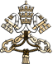  Read Online
April 25th  “Current laws in our country fail to protect the lives of unborn children. … People of good will must boldly stand up against this intrinsic evil [of abortion], especially when it is occurring on a massive scale, implemented in law and funded, in some instances, by the government.”  Most Reverend Joseph F. Naumann, Chair of the USCCB Committee on Pro-Life Activities, “Priorities at the Polls” | 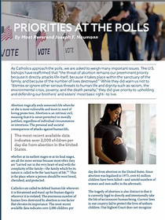  Download | Read Online

Word of Life – April 2021

Bulletin Art
You are welcome to use these, provided they are not altered in any way, other than the size. Thank you!

Sunday, April 11th, 2021
Download Images: https://www.usccb.org/resources/divine-mercy-images
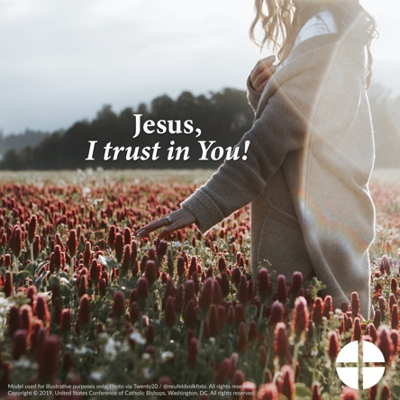

Sunday, April 18th / 25th, 2021

Download Images: https://www.usccb.org/resources/respect-life-graphics-no-taxpayer-abortion

