Word of Life: April 2021
Recommended dates are provided, but you are welcome to use these materials at any time!
Featured this Month…
April 11, 2021: Sunday of Divine Mercy
On the Second Sunday of Easter, the Church celebrates the Sunday of Divine Mercy. It provides an important opportunity to share Christ’s message of mercy, especially with those who have been wounded by participation in abortion. By the age of 45, as many as 1 in 3 women have had an abortion, and a similar number of men and family members have been involved. Many inaccurately feel that abortion is “the unforgivable sin.” They need to hear that God forgives every sin of a repentant heart, even the sin of abortion. In fact, Jesus’ message to St. Faustina is the greater the sinner, the greater the right to His mercy.
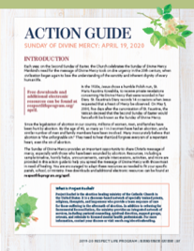
The Action Guide for the Sunday of Divine Mercy includes a sample timeline, simple steps, sample announcements, and an activity to help you bring Christ’s message of mercy to your parish community.
Prayer | Order
Check out respectlife.org/action-guides for supplemental resources.
Weekend(s) of April 11, 18 and/or 25, 2021: No Taxpayer Abortion
The website listed below is in the process of being built and will be ready by April 9.

Background: There’s a new push in Congress to force Americans to pay for abortion. The Hyde Amendment and other similar laws have protected taxpayers from funding elective abortion. Now, Congress wants to take away these laws, which have had broad public support for nearly 50 years. Without the Hyde Amendment, billions of dollars in healthcare funding could go to abortion.

Bulletin Announcement
Stop your tax dollars from going to abortion! www.NoTaxpayerAbortion.com

Graphics: https://www.usccb.org/resources/respect-life-graphics-no-taxpayer-abortion

