A STEWARDSHIP MOMENT

The Resurrection of the Lord – Easter Vigil
April 3, 2021

In tonight’s reading from Saint Paul’s letter to the Romans, we are reminded that we are alive in Christ. And it is not merely once a year that we remember what Jesus did to give us this new life, forgiveness and peace. Every day good stewards remember their baptism. They remember that they are united with Jesus in his death; that daily
they drown the old sinful nature, and that daily they rise to their new life in Christ. Let us be mindful every day, especially when we are troubled by life or tempted by sin, that our lives are no longer about us, but about Christ’s active, loving presence within us. That is our baptism. Alleluia! He is risen!

Easter Sunday
April 4, 2021

The tomb is empty! Jesus Christ has risen today! Our Savior is active, alive, and transforming us and our communities
of faith, even the world, at this very moment. Easter is a time of joy, a time of celebration. To have faith in the risen Lord is also to believe that we are disciples who bear witness to Christ in a broken and troubled world. To be good stewards of this faith obliges us to be living witnesses to Christ’s peace at home and in public. Jesus cannot be found buried. He is risen. Alleluia!

Second Sunday of Easter
Weekend of April 10/11, 2021

When the risen Christ encounters his disciples in the locked room he adds a new Beatitude to the ones we’ve heard proclaimed before: Blessed are those who have
not seen and have believed. Stewards of the mysteries
of God’s love do not need proof of the risen Christ. They know it because their lives have been transformed by the power of the Holy Spirit who has breathed new life into them. As stewards of this great gift it is appropriate to reflect on how we in turn add
new life into our parish communities.

Third Sunday of Easter
Weekend of April 17 / 18 2021

An underlying lesson from all three readings this
weekend is that the Risen Christ has wiped away our sins, not only for individuals, but throughout the world and its history. The terrible power of sin has now been reversed and our coming to perfection through the love of God is part of the Easter experience. As stewards of God’s love
we are called to participate in Christ’s redemptive activity. The steward questions for us are many: How do we
resist injustice at home or in the workplace? How do we confront violence in our language and attitudes? How do we bring Christ to others?

Fourth Sunday of Easter
Weekend of April 24 / 25 2021

In today’s Gospel reading we hear Jesus referring to himself as “the good shepherd.” His sheep know him, trust him, listen to him and follow him; having faith that no harm will come to them as long as they stay close to him. We reaffirmed our faith in Christ when we renewed our baptismal promises at Easter. As stewards of our relationship with Jesus Christ, are we, like the sheep, willing to listen to Jesus, follow him, trust him?

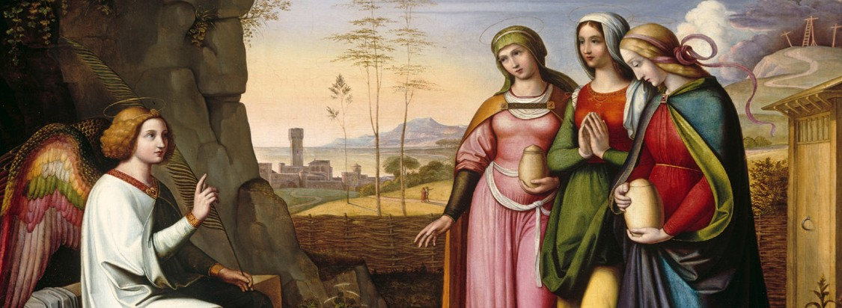International Catholic
Stewardship Council
ICSC@catholicstewardship.org
(800) 352-3452

www.catholicstewardship.com

