Lay Ecclesial
Ministry Training

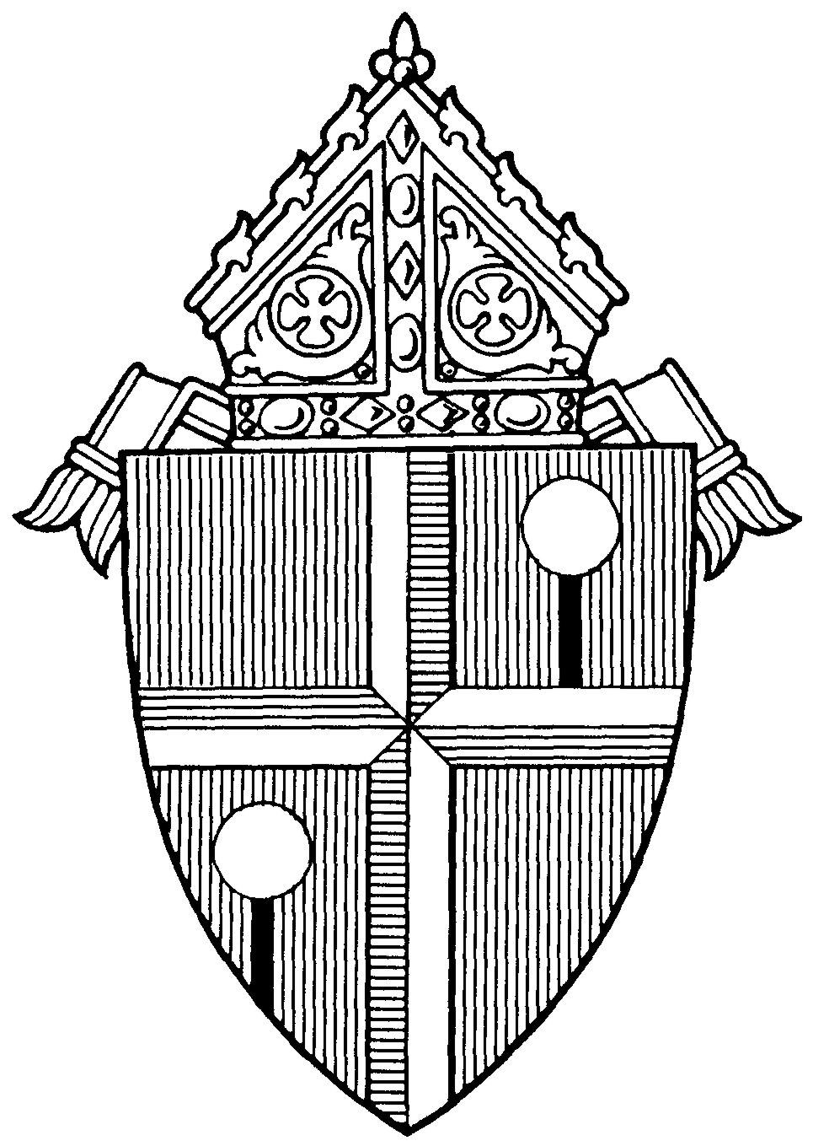
Diocese of Honolulu

RCIA Coordinators and
Team Members

LAY ECCLESIAL MINISTRY TRAINING
PROGRAM OVERVIEW

Go, therefore, and make disciples of all nations, baptizing them in the name of the Father, and of the Son, and of the Holy Spirit, teaching them to observe all that I have commanded you. And behold, I am with you always, until the end of the age. (Mt. 29: 19 – 20)

The Lay Ecclesial Ministry Certification Program provides both a basic foundation in Catholic theology and ministry-specific training. Together, they meet the six inter-related tasks for the development of the Christian faith as outlined in the National Directory for Catechesis: 1) to deepen knowledge of faith; 2) to provide a liturgical education that brings the faithful to full, conscious, and active participation in liturgy; 3) to provide a moral formation that transmits Jesus’ attitudes to the faithful in a way that leads to interior transformation; 4) to teach people to pray in such a way that catechesis is permeated by a climate of prayer; 5) to prepare the Christian to live in community; 6) to prepare Christians to participate actively in the life and mission of the Church.

Part I of this booklet outlines the theological foundations courses which are recommended of all lay ecclesial ministers in the Diocese of Honolulu, which include religious education catechists, teachers in the Hawaii Catholic Schools, youth ministers, young adult ministers, RCIA process team members and liturgical ministers.

Part II outlines the specialization courses for RCIA coordinators and team members. Specialization courses vary by ministry.

“It is clear that, in order to present the Catholic faith in its fullness and in a way that is attractive, those who catechize need preparation and ongoing formation specific to the conditions of those to whom they proclaim the Gospel message.” (NDC #54-A.8)

PART I: THEOLOGICAL FOUNDATIONS COURSES
Course Number and Title | Course Description
107  Sacred Scripture | The foundation of all evangelization and catechesis is the Word of God, especially as it finds expression in the Bible. Sacred Scriptures provides an overview of how we can effectively read, understand and use the Bible in our personal faith life as well as in catechetical settings.
108  Prayer and Spirituality | Prayer and Spirituality addresses our relationship with God and how He navigates us through the joys and difficulties of our spiritual life. Founded on Christ’s examples and teachings on prayer, we explore the diversity of the spiritual life, and practical applications to be utilized for personal growth.  Catechism of the Catholic Church pillar: “Christian Prayer”.
109  Catholic Creeds | In Catholic Creeds we reflect upon and articulate our personal faith, and understand more fully the truths we profess as members of a believing community so we can more confidently share our faith with others.  Catechism of the Catholic Church pillar: “The Profession of Faith”.
110  Catholic Morality | Catholic Morality examines how we are to live as Christians in and through Jesus, who describes himself as “the way, and the truth, and the life” (John 14:6).  Catechism of the Catholic Church pillar: “Life in Christ”.
111  Liturgy and Sacraments | We explore the meaning of liturgy and sacraments and gain insights into why the sacramental life of the faith community is so central to our Catholic identity.  Catechism of the Catholic Church pillar: “The Celebration of the Christian Mystery”
PART I: THEOLOGICAL FOUNDATIONS
TRACKING BOOKLET

All Theological Foundations and Specialization courses are to be completed within 3 years of beginning ministry with the diocese.

Theological Foundations Approved Course Options:
Diocesan-approved courses are available through:
- Echoes of Faith - Emmaus Edition (RCL Benziger) at www.flourishrclb.com
- My Catholic Faith Delivered at www.mycatholicfaithdelivered.com
- STEP Notre Dame mcgrath.nd.edu/online-courses/step/
- University of Dayton, Virtual Learning Community for Faith Formation (VLCFF) at vlcff.udayton.edu
- Catechetical Foundations courses offered through the Office for Youth and Young Adult Ministry (OYYAM)
- Catechesis of the Good Shepherd (through certified CGS international formation leaders)
- Annual faith formation conferences
- Parish-based training programs
- Accredited college or university

Using this Tracking Booklet:
Individuals should use this booklet to help keep track of all the various courses as they are completed. Note that you must provide proof of completion for each course to your Pastor, or the person who oversees the RCIA (i.e. DRE, RCIA Coordinator, Pastoral Associate). They will sign the booklet for the relevant course after you provide them with proof of completion for that course.

Once all Theological Foundation and Specialization courses are finished, the entire completed booklet should be submitted to your RCIA Ministry Leader so they may provide a copy of it to the diocese.
Name: ____________________________________________________

Phone: ____________________________________________________

Parish: ____________________________________________________

Email: ____________________________________________________

PART I: THEOLOGICAL FOUNDATIONS COURSES
107 Sacred Scripture |  | Date Completed:
Select One:
 | Echoes of Faith: The Scriptures
 | My Catholic Faith Delivered : Scripture
 | STEP Notre Dame: Introduction to the New Testament
 | VLCFF: Bible Basics
 | Foundations Course Offered through OYYAM: Scripture
Catechesis of the Good Shepherd: Part One Training,
All Levels
 | Faith Formation Conference: (session title)
 | Other:
Pastor/Principal/Parish Ministry Leader Signature

_____________________

Print Name: Date:

108 Prayer and Spirituality |  | Date Completed:
Select One:
 | Echoes of Faith: Prayer and Spirituality
 | My Catholic Faith Delivered: Foundations: Prayer and Spirituality
 | STEP Notre Dame: On Prayer
 | VLCFF: Introduction to Prayer
 | Foundations Course Offered through OYYAM: Prayer and Spirituality
Catechesis of the Good Shepherd: Part One Training,
All Levels
 | Faith Formation Conference: (session title)
 | Other:
Pastor/Principal/Parish Ministry Leader Signature

_______________________________
Print Name: Date:

109 Catholic Creeds |  | Date Completed:
Select One:
 | Echoes of Faith: I Believe/We Believe
 | My Catholic Faith Delivered: Foundations: Creed
 | STEP Notre Dame: Creed
 | VLCFF: Catholic Beliefs
 | Foundations Course Offered through OYYAM: Creed
 | Catechesis of the Good Shepherd: Part One Training, All Levels
 | Faith Formation Conference: (session title)
 | Other:
Pastor/Principal/Parish Ministry Leader Signature

______________________________

Print Name: Date:

110 Catholic Morality |  | Date Completed:
Select One:
 | Echoes of Faith: Catholic Morality
 | My Catholic Faith Delivered: Foundations: Life in Christ
 | STEP Notre Dame: The Christian Conscience and Ethical Dilemmas
 | Foundations Course Offered through OYYAM: Christian Morality
 | VLCFF: Introduction to Christian Morality
 | Catechesis of the Good Shepherd: Part One Training, All Levels
 | Faith Formation Conference: (session title)
 | Other:
Pastor/Principal/Parish Ministry Leader Signature

_______________________________

Print Name: Date:

111 Liturgy and Sacraments |  | Date Completed:
Select One:
 | Echoes of Faith: Liturgy and Sacraments
 | My Catholic Faith Delivered: Foundations: Liturgy and Sacraments
 | STEP Notre Dame: Liturgical Theology
 | VLCFF: Introduction to Liturgy and Introduction to Sacraments
 | Foundations Course Offered through OYYAM: Liturgy and Sacraments
 | Catechesis of the Good Shepherd: Part One Training, All Levels
 | Faith Formation Conference: (session title)
 | Other:
Pastor/Principal/Parish Ministry Leader Signature
_______________________________
Print Name: Date:

Part II: RCIA COORDINATOR AND TEAM MEMBER
SPECIALIZATION COURSES

Recall that you are asked to complete both the Theological Foundations and the RCIA Specialization courses within 3 years of beginning ministry with the diocese.

Note that you must provide proof of completion for each course to your Pastor, or the person who oversees the RCIA (i.e. DRE, RCIA Coordinator, Pastoral Associate). Once all Theological Foundation and Specialization courses are finished, the entire completed booklet should be submitted to your RCIA Ministry Leader so they may provide a copy of it to the diocese.

All RCIA Coordinators and Team Members are asked to take Overview of RCIA. In addition, you are asked to take EITHER Facilitating Small Groups or The Task of Catechesis.

Part II: RCIA SPECIALIZATION COURSES
Course Number & Title | Course Description
410  Overview of RCIA | Learn about the four periods and the three ritual steps of the RCIA process. Learn to distinguish between catechumens and candidates and why this distinction is so important. Learn about adaptations of RCIA for children as well as year round and lectionary based models for running your RCIA process.
411  Facilitating Small Groups | At its heart, RCIA is a small group process. This session prepares you for the task of facilitating small faith sharing groups. Adult learning styles and the role of relationships for adult faith formation will also be examined.
412  The Task of Catechesis | Explore the aim of catechesis, the six tasks that make up catechesis and how different learning styles impact the task of catechesis, all discussed within the context of the RCIA process.
Part II: RCIA SPECIALIZATION COURSES

Name: ____________________________________________________

Phone: ____________________________________________________

Parish: ____________________________________________________

Email: ____________________________________________________

410 Overview of RCIA |  | Date Completed:
Select One:
 | TeamRCIA Online Course with supplemental discussion: Video Marathon: An RCIA Drill Down
 | VLCFF Online Course: RCIA
 | STEP Notre Dame Online Course: RCIA: Can We Get the Rite Right?
 | Liturgy Training Publications Online Workshop: Preparing the Liturgies of the RCIA
 | Faith Formation Conference: (session title)
 | Other:
Pastor/RCIA Coordinator Signature

_______________________________

Print Name: Date:

Take EITHER Facilitating Small Groups OR Task of Catechesis

411 Facilitating Small Groups |  | Date Completed:
Select One:
 | Echoes of Faith: Adult Faith Formation
Team RCIA Webinar with supplemental discussion: Little Known Ways to Turn Your RCIA into an Adult Process (Even For Children)
AND
Team RCIA Webinar with supplemental discussion: Six Signs of Conversion that Must Happen in the RCIA
 | VLCFF Online Course: Foundations and Vision for Adult Learning and Faith Formation
 | STEP Notre Dame Online Course: RCIA: Can We Get the Rite Right?
 | Faith Formation Conference: (session title)
 | Other:
Pastor/RCIA Coordinator Signature

_______________________________

Print Name: Date:

412 The Task of Catechesis |  | Date Completed:
Select One:
 | TeamRCIA Online Course with supplemental discussion: Video Marathon: The Tasks of Catechesis
 | VLCFF Online Course: Introduction to Catechesis
 | STEP Notre Dame Online Course: The Six Tasks of Catechesis
 | Liturgy Training Publications Online Workshop with supplemental discussion: Liturgical Catechesis in the RCIA: Forming Catechumens, Candidates and the Assembly
 | Faith Formation Conference: (session title)
 | Other:
Pastor/RCIA Coordinator Signature

_______________________________

Print Name: Date:

Ongoing Formation for RCIA Coordinators and Team Members Faith formation is a life-long process that requires continual participation and engagement. Ongoing formation may include personal reading, Catholic retreats, pilgrimages, college courses in theology, attending a variety of local and national training sessions or conferences, etc.

Highly Recommended Ongoing Formation Offerings:
The 3rd RCIA specialization course (Facilitating Small Groups or The Task of Catechesis, whichever you have not completed.)

My Catholic Faith Delivered
- Theology of the Body for Adults/Educators

VLCFF
- Introduction to the Sacraments of Initiation
- Parish as a Learning Community
- Vocation, Spirituality and Discipleship of Catechists

Diocese of Honolulu
Office of Worship
1184 Bishop Street
Honolulu, Hawaii 96813
(808) 585-3342 office
mcordero@rcchawaii.org

