Religious Education Catechist

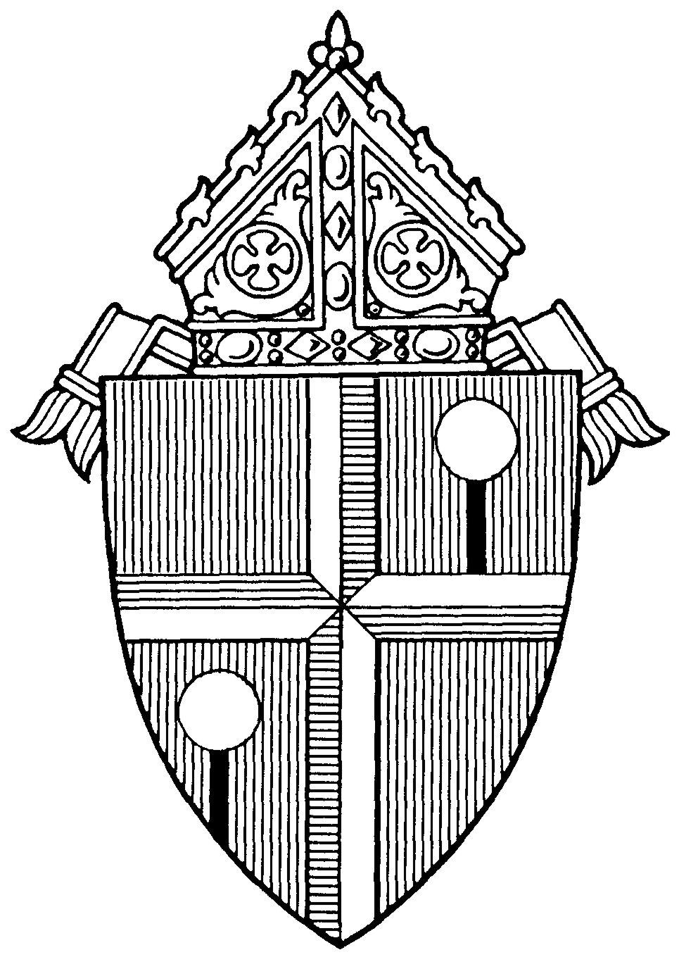

Lay Ecclesial
Ministry Training

Diocese of Honolulu

LAY ECCLESIAL MINISTRY TRAINING
PROGRAM OVERVIEW

Go, therefore, and make disciples of all nations, baptizing them in the name of the Father, and of the Son, and of the Holy Spirit, teaching them to observe all that I have commanded you. And behold, I am with you always, until the end of the age. (Mt. 29: 19 – 20)

The Lay Ecclesial Ministry Certification Program for catechists provides both a basic foundation in Catholic theology and ministry-specific training. Together, they meet the six inter-related tasks for the development of the Christian faith as outlined in the National Directory for Catechesis: 1) to deepen knowledge of faith; 2) to provide a liturgical education that brings the faithful to full, conscious, and active participation in liturgy; 3) to provide a moral formation that transmits Jesus’ attitudes to the faithful in a way that leads to interior transformation; 4) to teach people to pray in such a way that catechesis is permeated by a climate of prayer; 5) to prepare the Christian to live in community; 6) to prepare Christians to participate actively in the life and mission of the Church.

Part I of this booklet outlines the theological foundations courses which are recommended of all lay ecclesial ministers in the Diocese of Honolulu, which include religious education catechists, teachers in the Hawaii Catholic Schools, youth ministers, young adult ministers, RCIA process team members and liturgical ministers.

Part II outlines the specialization courses for parish religious education catechists. Specialization courses vary by ministry.

“It is clear that, in order to present the Catholic faith in its fullness and in a way that is attractive, those who catechize need preparation and ongoing formation specific to the conditions of those to whom they proclaim the Gospel message.” (NDC #54-A.8)
Personal Qualities of a Catechist

The Church calls forth exemplary followers of Christ who have a living, conscious, active participation in the sacramental life of the Church. Personal qualities of catechists should include:

- faith that manifests itself in their piety and daily life;
- love for the Church; apostolic spirit and missionary zeal;
- love for their brothers and sisters and a desire to give generous service;
- a willingness to continue their own religious education and formation;
- the human, moral, and technical qualities necessary for the ministry of a catechist such as dynamism and good relationships with others;
- respect for the diversity of cultures;
- an ability to appreciate different stages of individual growth and development;
- an ability to communicate effectively with the persons to be catechized.
- These general qualities will have to be made more specific for local conditions and applied to the particular circumstances in each area [see NDC, p. 236].

PART I: THEOLOGICAL FOUNDATIONS COURSES
Course Number and Title | Course Description
107  Sacred Scripture | The foundation of all evangelization and catechesis is the Word of God, especially as it finds expression in the Bible. Sacred Scriptures provides an overview of how we can effectively read, understand and use the Bible in our personal faith life as well as in catechetical settings.
108  Prayer and Spirituality | Prayer and Spirituality addresses our relationship with God and how He navigates us through the joys and difficulties of our spiritual life. Founded on Christ’s examples and teachings on prayer, we explore the diversity of the spiritual life, and practical applications to be utilized for personal growth.  Catechism of the Catholic Church pillar: “Christian Prayer”.
109  Catholic Creeds | In Catholic Creeds we reflect upon and articulate our personal faith, and understand more fully the truths we profess as members of a believing community so we can more confidently share our faith with others.  Catechism of the Catholic Church pillar: “The Profession of Faith”.
110  Catholic Morality | Catholic Morality examines how we are to live as Christians in and through Jesus, who describes himself as “the way, and the truth, and the life” (John 14:6).  Catechism of the Catholic Church pillar: “Life in Christ”.
111  Liturgy and Sacraments | We explore the meaning of liturgy and sacraments and gain insights into why the sacramental life of the faith community is so central to our Catholic identity.  Catechism of the Catholic Church pillar: “The Celebration of the Christian Mystery”

PART I: THEOLOGICAL FOUNDATIONS
TRACKING BOOKLET

All Theological Foundations and Specialization courses are to be completed within 3 years of beginning ministry with the diocese.

Theological Foundations Approved Course Options:
Diocesan-approved courses are available through:
- Echoes of Faith - Emmaus Edition (RCL Benziger) at www.flourishrclb.com
- My Catholic Faith Delivered at www.mycatholicfaithdelivered.com
- STEP Notre Dame mcgrath.nd.edu/online-courses/step/
- University of Dayton, Virtual Learning Community for Faith Formation (VLCFF) at vlcff.udayton.edu
- Catechetical Foundations courses offered through the Office for Youth and Young Adult Ministry (OYYAM)
- Catechesis of the Good Shepherd (through certified CGS international formation leaders)
- Annual faith formation conferences
- Parish-based training programs
- Accredited college or university

Using this Tracking Booklet:
Individuals should use this booklet to help keep track of all the various courses as they are completed. Note that you must provide proof of completion for each course to your Pastor, Catholic School Principal or Ministry Coordinator. They will sign the booklet for the relevant course after you provide them with proof of completion for that course.

Once all Theological Foundation and Specialization courses are finished, the entire completed booklet should be submitted to your Principal or Ministry Coordinator so they may provide a copy of it to the diocese.
Name: ____________________________________________________

Phone: ____________________________________________________

Parish: ____________________________________________________

Email: ____________________________________________________

PART I: THEOLOGICAL FOUNDATIONS COURSES

107 Sacred Scripture |  | Date Completed:
Select One:
 | Echoes of Faith: The Scriptures
 | My Catholic Faith Delivered : Scripture
 | STEP Notre Dame: Introduction to the New Testament
 | VLCFF: Bible Basics
 | Foundations Course Offered through OYYAM: Scripture
Catechesis of the Good Shepherd: Part One Training,
All Levels
 | Faith Formation Conference: (session title)
 | Other:
Pastor/Principal/Parish Ministry Leader Signature

_____________________

Print Name: Date:

108 Prayer and Spirituality |  | Date Completed:
Select One:
 | Echoes of Faith: Prayer and Spirituality
 | My Catholic Faith Delivered: Foundations: Prayer and Spirituality
 | STEP Notre Dame: On Prayer
 | VLCFF: Introduction to Prayer
 | Foundations Course Offered through OYYAM: Prayer and Spirituality
Catechesis of the Good Shepherd: Part One Training,
All Levels
 | Faith Formation Conference: (session title)
 | Other:
Pastor/Principal/Parish Ministry Leader Signature

_______________________________
Print Name: Date:

109 Catholic Creeds |  | Date Completed:
Select One:
 | Echoes of Faith: I Believe/We Believe
 | My Catholic Faith Delivered: Foundations: Creed
 | STEP Notre Dame: Creed
 | VLCFF: Catholic Beliefs
 | Foundations Course Offered through OYYAM: Creed
 | Catechesis of the Good Shepherd: Part One Training, All Levels
 | Faith Formation Conference: (session title)
 | Other:
Pastor/Principal/Parish Ministry Leader Signature

______________________________

Print Name: Date:

110 Catholic Morality |  | Date Completed:
Select One:
 | Echoes of Faith: Catholic Morality
 | My Catholic Faith Delivered: Foundations: Life in Christ
 | STEP Notre Dame: The Christian Conscience and Ethical Dilemmas
 | Foundations Course Offered through OYYAM: Christian Morality
 | VLCFF: Introduction to Christian Morality
 | Catechesis of the Good Shepherd: Part One Training, All Levels
 | Faith Formation Conference: (session title)
 | Other:
Pastor/Principal/Parish Ministry Leader Signature

_______________________________

Print Name: Date:

111 Liturgy and Sacraments |  | Date Completed:
Select One:
 | Echoes of Faith: Liturgy and Sacraments
 | My Catholic Faith Delivered: Foundations: Liturgy and Sacraments
 | STEP Notre Dame: Liturgical Theology
 | VLCFF: Introduction to Liturgy and Introduction to Sacraments
 | Foundations Course Offered through OYYAM: Liturgy and Sacraments
 | Catechesis of the Good Shepherd: Part One Training, All Levels
 | Faith Formation Conference: (session title)
 | Other:
Pastor/Principal/Parish Ministry Leader Signature
_______________________________

Print Name: Date:

PART II: RELIGIOUS EDUCATION CATECHIST SPECIALIZATION COURSES
Course Number and Title |  | Course Description
103  Characteristics of Human Development |  | The National Directory for Catechesis reminds us that “God reveals himself to us gradually and in stages, drawing us ever closer in order to prepare us to welcome the culmination of God’s self-revelation in …Jesus Christ” (NDC 16A). In understanding the continuous cycle of growth and development that occurs throughout life we are better equipped to partner with parents to engage children in an exciting journey of faith.
104  Roles of the Catechist |  | Catechists are more than “content experts”! We are members of the Church community who have received and responded to a call from God to assist parents in forming their children in faith. The Roles of the Catechist focuses on our key roles.
105  Child and Youth Ministry and the Law |  | Discussion of the essential information concerning civil law and its impact on Church institutions, programs and catechetical personnel.
222  224  226 | Methods for Teaching:  Grades 1 and 2  Grades 3 and 4  Grades 5 and 6 | Methods courses provide an introduction to the child’s unique learning needs and age-appropriate ways to evangelize and catechize in parish religious education programs.  Methods for students in grades 6 – 12 are provided in Youth Ministry specialization training courses.

RELIGIOUS EDUCATION CATECHIST
SPECIALIZATION COURSES

Theological Foundations and Specialization courses are to be completed within 3 years of beginning ministry with the diocese.

Ministry leaders: Submit form to the diocesan Office of Religious Education upon completion of all RE specialization courses.

Name: ____________________________________________________

Phone: ____________________________________________________

Parish: ____________________________________________________

Email: ____________________________________________________

103 Characteristics of Human Development |  | Date Completed:
Select One:
 | Echoes of Faith: The Learner
 | My Catholic Faith Delivered: Catechesis 101: Those Who Are Catechized
 | VLCFF: Introduction to Catechesis: Tasks of Catechesis & Learning Styles
 | Catechesis of the Good Shepherd: Part One Training, All Levels
 | Faith Formation Conference: (session title)
 | Other:
Pastor/Director/Coordinator of Religious Education Signature ________________________

Print Name: Date:

104 Roles of the Catechist |  | Date Completed:
Select One:
 | Echoes of Faith: Roles of the Catechist
 | My Catholic Faith Delivered: Catechesis 101: Those Who Are Catechized
 | VLCFF: Introduction to Catechesis: Vocation of the Catechist & Roles of Catechesis
 | Catechesis of the Good Shepherd: Part One Training, All Levels
 | Faith Formation Conference: (session title)
 | Other:
Pastor/Director/Coordinator of Religious Education
Signature ________________________

Print Name: Date:

105 Child and Youth Ministry and the Law |  | Date Completed:
Select One:
 | Office of Religious Education: Religious Education and the Law
 | VLCFF: Administration in Ministry
 | Faith Formation Conference: (session title)
 | Other:
Pastor/Director/Coordinator of Religious Education Signature ________________________

Print Name: Date:

222 METHODOLOGY (Select One)
Echoes of Faith |  | Date Completed:
 | Methods for Teaching Grades 1 and 2
 | Methods for Teaching Grades 3 and 4
 | Methods for Teaching Grades 5 and 6
Select One:
 | My Catholic Faith Delivered:Catechesis 101: Methodology – Parts 1 & 2
 | VLCFF:Introduction to Catechesis: Process, Methods & Lesson Planning in Catechesis
 | Catechesis of the Good Shepherd: Part One Training, All Levels
 | Faith Formation Conference: (session title)
 | Other:
Pastor/Director/Coordinator of Religious Education Signature ________________________

Print Name: Date:

Highly Recommended for Catechists
My Catholic Faith Delivered
- Theology of the Body for Middle School, High School, Adults/Educators

VLCFF
- Catholic Teaching on Chastity, Family Life & Human Sexuality Education
- Mary in Scripture and Tradition
- Disabilities in Parish Life
ONGOING FORMATION
Faith formation is a life-long process that requires continual participation and engagement. Ongoing formation may include personal reading, Catholic retreats, pilgrimages, college courses in theology, attending a variety of local and national training sessions or conferences, etc.

MASTER CATECHIST CERTIFICATION
Catechists, particularly those in positions of leadership, are encouraged to earn a Master Catechist Certification by completing a Certificate in Catechesis through the University of Dayton’s Virtual Learning Community for Faith Formation (VLCFF).

The University of Dayton in partnership with the Diocese of Honolulu provides consistent, high quality training and education for persons involved in catechetical ministries. Upon successful completion of the Certificate of Catechesis, participants will receive both a certificate of completion from the University of Dayton and a certificate of recognition as Master Catechist by the Diocese of Honolulu.

Access the Certificate in Catechesis at https://vlcff.udayton.edu

Catechists holding a master’s degree or its equivalent in theology, religious studies, or related fields may be recognized as a Master Catechist. Contact the Office of Religious Education for details.

NOTES:

NOTES:

Diocese of Honolulu
Office of Religious Education
St. Stephen Diocesan Center
6301 Pali Highway
Kaneohe, Hawaii 96744
www.catholichawaii.org/catechist
(808) 203-6747 office
(808) 261-7022 fax

