Inserts for Bulletins, Newsletters & Websites
Insert #1

Please use these five reflections on the Original Order in your parish bulletins, in your newsletters and on your parish website or MyParish App. Authorship credit need only be given to the Diocese of Honolulu. Consider using them consecutively for any five week period. Each reflection is between 200-215 words, but you can cut it into even shorter segments if you wish. Reformat them for your parish bulletin if you wish.

A good time to consider starting these reflections would be: with the start of the new school year; beginning September 1; beginning with the First Week of Advent; or beginning with the Sunday Feast of the Baptism of the Lord.

Questions, Comments Suggestions?
Contact Kristina DeNeve, Adult Faith Formation Coordinator
kdeneve@rcchawaii.org or 808-203-6767

Receiving Sacraments “Out of Order”
Reflections on the Original Order
Diocese of Honolulu
Questions? kdeneve@rcchawaii.org
Did you know that children baptized as infants usually receive the sacraments out of sequence, out of order? To be fully initiated as Christians, as followers of Jesus Christ, we receive three sacraments, namely Baptism, First Communion and Confirmation. When Confirmation comes last, perhaps even years after First Communion, we can get the impression that Confirmation is the “final” sacrament, that Confirmation is what brings us fully into the Body of Christ.

This is not true. Our faith tells us that Eucharist, not Confirmation, is the source and summit of our faith. Our faith tells us that First Communion is what completes our initiation into the life of Christ.

In 1971, Blessed Pope Paul VI issued the revised Rite of Confirmation saying “The faithful are born anew by Baptism, strengthened by the sacrament of Confirmation, and finally are sustained by the food of eternal life in the Eucharist…… the faithful, after being signed by holy Baptism and Confirmation, are incorporated fully into the body of Christ by participation in the Eucharist” (Apostolic Constitution, “Divinae Consortium Naturae,” 1971).

Over the coming weeks, we’ll more fully explore these three sacraments as well as the upcoming changes our diocese is making to establish the original order of the three sacraments of initiation.

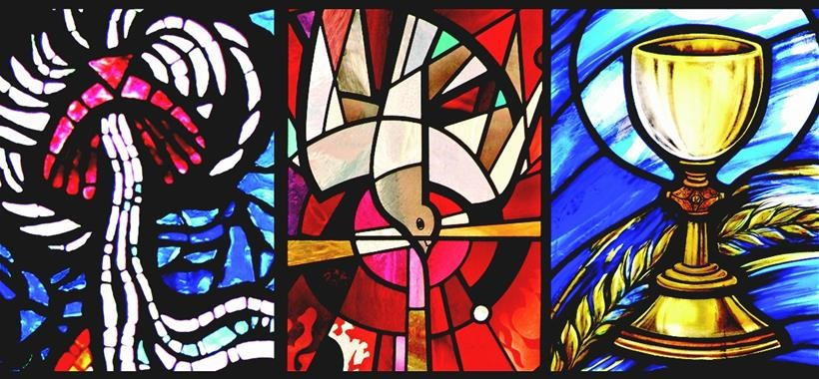

The Original Order Corner
Inserts for Bulletins, Newsletters & Websites
Insert #2

Questions, Comments Suggestions?
Contact Kristina kdeneve@rcchawaii.org or
808-203-6767

Thinking About the Sacraments of Initiation
Reflections on the Original Order
Diocese of Honolulu
Questions? kdeneve@rcchawaii.org
“The (three) sacraments of Christian initiation lay the foundations of every Christian life” Catechism of the Catholic Church, no.1212. Indeed, the initiation sacraments can be compared to climbing up Diamond Head Crater. To do the climb, one needs to be prepared when starting out, primarily by being hydrated. Then one needs the strength to climb up the 3/4-mile path. Finally, one reaches the summit and can enjoy the magnificent view in every direction.

This corresponds to the sacraments of initiation. The hydration of Baptism starts a Christian on the path. The gift of the Holy Spirit received in Confirmation gives the strength needed to make the journey. Then finally, earth is joined to heaven at the summit when one receives first Holy Communion.

Notice that what completes our membership into the Body of Christ is not Confirmation. Rather, it is receiving First Communion. The truth is that the first two sacraments (Baptism and Confirmation) are what prepare us for Eucharist. From our own experience we know that Eucharist does not prepare us for Confirmation. It is the other way around.

The sacraments that initiate us into the Christian life are first of all Baptism, then Confirmation, and finally, First Holy Communion.

The Original Order Corner
Inserts for Bulletins, Newsletters & Websites
Insert #3

Questions, Comments Suggestions?
Contact Kristina kdeneve@rcchawaii.org or
808-203-6767

Baptism, Confirmation and Then First Communion
Reflections on the Original Order
Diocese of Honolulu
Questions? kdeneve@rcchawaii.org
The sacraments that initiate us into the Christian life are Baptism and Confirmation. Baptism and Confirmation go hand in hand, like a certificate given its official seal. In Baptism, Christians share in the death and resurrection of Jesus. In Confirmation, the Holy Spirit comes down upon us as it did on the Apostles on the day of Pentecost. Baptism and Confirmation are as inseparable as Easter and Pentecost Sundays, the first and last days of the Easter season.

Jesus himself was baptized and then confirmed by his Father with the gift of the Spirit: “After Jesus was baptized, he came up from the water and, behold, the heavens were opened for him, and he saw the Spirit of God descending like a dove and coming upon him. And a voice came from the heavens, saying, ‘This is my beloved Son, with whom I am well pleased’” (Matthew 3:16-17).

In the Rite of Christian Initiation of Adults, the sacraments are received in the proper theological order, usually at the Easter vigil — Baptism, Confirmation, and then first Holy Communion. This takes place for anyone 7 years of age and older. Soon, our children baptized as infants will also be confirmed prior to First Communion.

The Original Order Corner
Inserts for Bulletins, Newsletters & Websites
Insert #4

Questions, Comments Suggestions?
Contact Kristina kdeneve@rcchawaii.org or
808-203-6767

Confirmation is Not a Passage Into Adulthood
Reflections on the Original Order
Diocese of Honolulu
Questions? kdeneve@rcchawaii.org
Many Catholic Christians see Confirmation as a rite of passage into adulthood. Yet Confirmation is a sacrament of beginning, of initiation. It is not a sacrament of transition, of becoming an adult.

The Catechism states, “Although Confirmation is sometimes called the ‘sacrament of Christian maturity,’ one must not confuse adult faith with the adult age of natural growth. … Age of body does not determine age of soul. Even in childhood one can attain spiritual maturity.” (no. 1308)

In the Eastern Catholic Churches, infants are routinely confirmed (“Chrismation” in the eastern traditions). In the Roman Catholic Church, young children in danger of death are confirmed. At the other end of the age spectrum, if an elderly person is baptized, then he or she is immediately confirmed. The fact that infants, children, teenagers, young adults and the elderly can all be confirmed shows that Confirmation is not about becoming an adult. It is about being sealed with the gift of the Holy Spirit.

Soon, seven year-olds who were baptized as infants will complete their sacraments of initiation in this original order. (When this will happen depends on your parish plan.) Specifically, children will be confirmed prior to receiving First Communion. They will not “transition” into adulthood. They will be fully initiated into our faith.

The Original Order Corner
Inserts for Bulletins, Newsletters & Websites
Insert #5

Questions, Comments Suggestions?
Contact Kristina kdeneve@rcchawaii.org or
808-203-6767

Confirmation is Not Us Confirming Our Faith
Reflections on the Original Order
Diocese of Honolulu
Questions? kdeneve@rcchawaii.org
Sometimes Catholics approach Confirmation like a graduation, saying, “I made my Confirmation,” as if it is something that they earned after completing X number of service hours or attending Y percentage of Confirmation classes. But, that is not what Confirmation means.

We the baptized do not “confirm” our faith in the sacrament of Confirmation. Rather, it is God who confirms us in the free gift of our faith: “He has put his seal on us and given us his Spirit in our hearts as a guarantee” Ephesians 1:13, 4:30

Pope Francis addressed this point in his general audience of Jan. 29, 2014: “Confirmation, like every sacrament, is not the work of men but of God, who cares for our lives in such a manner as to mold us in the image of his Son, to make us capable of loving like him. God does it by infusing in us his Holy Spirit, whose action pervades the whole person and his/her entire life.”

Soon, seven year-olds who were baptized as infants will be confirmed prior to receiving First Communion. (When this will happen depends on your parish plan.) God will perfect in them the grace received at Baptism, perfect in them the common priesthood of all the faithful (Catechism of the Catholic Church, Nos. 1305 and 1316).

